**RMBI4990 Final Report - Credit Scoring (Predictive Analysis)**

**Group 2**

**Abstract**

Credit scoring is a statistical analysis performed by financial services companies to determine the creditworthiness of their customers in the credit approval process (Thomas, 2021). While granting loans is one of their major sources of income, loan defaults could bring detrimental effects to their profitability. Credit scoring models are therefore to be updated periodically to improve model accuracy in predicting whether a loan applicant will default or not. However, the challenges are that the model updating process requires high time cost, human resources cost, and high expertise requirements. This project therefore proposes an automated credit scoring model development pipeline in the form of a Dataiku project for Sprint Milestone’s clients to solve the problems. Intuitive graphical interfaces are provided within the pipeline to introduce simplicity and improve efficiency in building and updating the credit scoring model of financial institutions.

The pipeline proposed has 5 components, including automated binning, interactive binning, visualization dashboard, credit scoring model, and an automated reject inference solution. A credit risk dataset collected from Kaggle, along with randomly generated samples is used for assisting in the implementation of building the pipeline and performing testing. Dataiku recipes, charts, automatic machine-learning tools, web apps, and dashboards are used for implementing the pipeline.

At the end of the project, we expect an all-in-one credit scoring solution facilitating the efficiency and accuracy of the credit approval process. Our solution will start with automated binning algorithms which help generate the initial binnings automatically. Then, based on the visualization dashboard we designed, users can have a better understanding of the binning performance and make use of the interactive binning interface for further manual adjustments. After the data pre-processing stage, various options of credit scoring models will be provided, and users can choose the best fit model based on their performance on the automatically generated model report. Finally, an automated reject inference solution will also be implemented to further reduce sample bias and expand the potential customers our bank clients can serve.

Table of Content

1. Introduction
   1. Project Background
   2. Industry and Company Background
   3. Challenges
   4. Aims and Objectives
   5. Overview
2. Literature Review
   1. Introduction
   2. Recent Development of Credit Scoring
      1. Credit Scoring and Its Importance
      2. Traditional Credit Scoring Process
   3. Binning
      1. Good Binning Criteria
      2. Automated Binning
         1. Comparison between Automated Binning Algorithms
         2. Limitations of Automated Binning
      3. Interactive Binning
         1. MATLAB Binning Explorer
      4. Comparison between Automated Binning & Interactive Binning
   4. Visualization Dashboard
   5. Credit Scoring Models
      1. Recent Development of Credit Scoring Models
         1. Linear Regression
         2. Logistic Regression
         3. Decision Tree
         4. Random Forest
         5. Support Vector Machine
         6. Gradient Tree Boosting
         7. Extreme Gradient Boost (XGBoost)
         8. Neural Networks
      2. Comparison of Different Credit Scoring Models
   6. Reject Inference
      1. Comparison between Reject Inference Approaches
   7. Conclusion
3. Methodology
   1. Introduction
   2. Kaggle Credit Risk Dataset
      1. Data Nature
   3. Dataiku Platform
   4. Credit Scoring Model Development Pipeline
   5. Data Pre-Processing
      1. Automated Binning
      2. Interactive Binning
         1. Generation of Paid Past Due Column
         2. Web App Frameworks for Interactive Binning
         3. Functionalities and UI Design
            1. Display Input Dataset
            2. Define Good and Bad Definition
            3. Interactive Binning
            4. Binning Preview & Summary
            5. Save Bin Settings
         4. Dash Web Application
         5. Python Recipe
      3. Visualization Dashboard
         1. Summary Statistics Table
         2. Mixed Chart
         3. Python Recipe
         4. Prepare Recipe
         5. Charts
         6. Dashboard
   6. Credit Scoring Model Development - Auto Machine Learning
   7. Reject Inference
      1. Assigning all Rejects to Bad
      2. Auto Machine Learning
      3. Naice Bayes
      4. Reject Inference Implementation
   8. Summary
4. Implementation
   1. Adjustment in Automated Binning
   2. Adjustment in Interactive Binning
   3. Final Credit Scoring Model Pipelines
5. Project Evaluation and Discussion
   1. Introduction
   2. Unit testing
   3. User Acceptance Test
6. Conclusion and Future Work
7. Reference and Appendix

**1. Introduction**

**1.1 Project Background**

Credit scoring is a statistical analysis performed by financial services companies to determine the creditworthiness of their customers in the credit approval process (Thomas, 2021). Many financial institutions are continually creating and updating their credit scoring models, utilizing a wide range of data and newly emerging technologies such as machine learning to understand their customers better. While granting loans is one of the major sources of income to financial companies, loan defaults could bring detrimental effects to their profitability. The credit scoring process that is used to determine loan approval and rejection, therefore, becomes important with the intention to minimize the risk of loan losses and delinquency rates due to the costly misclassifying error. On that account, an automated credit scoring model development pipeline is imperative for improving time efficiency, and human resource efficiency, and lowering technical barriers to the credit scoring model development process. This directly links to an improvement in the risk-adjusted profitability of financial institutions.

**1.2 Industry and Company Background**

Sprint Milestones is a strategy and analytics consultancy that helps clients leverage their data for high performance. (Sprint Milestones, N.A.) They specialize in data management, business intelligence, and predictive analytics by providing training and coaching to their clients around the world and assisting them to build their own teams and analytics capabilities.

Within their client base are fintech and financial services companies that provide loans to their customers. These companies aim at balancing risk and profitability in the credit approval process. To perform credit scoring, traditionally, patterns and trends are extracted from credit reports to determine risk characteristics. Attributes such as age and income are evaluated in point values on a table called credit scorecard. Financial institutions would determine the minimum level of credit score they approve for credit according to their risk appetite. However, in recent decades, the approaches for credit scoring have increased in sophistication given the rise of emerging technologies such as machine learning. The credit scoring process, as a result, has been complicated within the industry.

**1.3 Challenges**

As mentioned in Section 1.2, the credit scoring process has evolved to become complex. Financial institutions no longer simply use the credit scorecard along with credit reports provided by credit scoring agencies to make decisions about credit approval or rejection. They make use of internal data such as customer historical data, perform data binning, and feed into machine learning models such as logistic regression, and do reject inference, to improve the prediction accuracy of whether their customer will default or not. All these steps require time, human resources, and expertise to perform.

First, sophisticated algorithms are needed to perform data binning. In order to enhance model prediction accuracy, high predictive power features to be input into the model have to be constructed. To enhance the predictive power of features input to the credit scoring model, numerical variables such as age and income are categorized into bins with distinctive patterns, while categorical variables such as loan grading and educational level may have their bins combined. Besides improving predictive power, other regulatory constraints such as grouping the age groups with higher risk (i.e., the older generations and young people) should also be taken into account in the binning process. This makes the algorithms for performing data binning complex, increasing the resources and expertise required for this step.

Second, in order to find the optimized credit scoring model for predicting customers’ creditworthiness, many different combinations of binning and model architectures have to be trained and evaluated on their performances. This requires high expertise in building the models and high human resources and time costs for performing model training.

Third, reject inference takes into account the data of customers who have been rejected in the credit approval process. It reduces the model bias, and hence, enhances model prediction accuracy, but at a cost of time, human resources, and expertise. Training and tuning of models are also required, leading to an inefficient credit scoring model development process.

In order to reduce the time, human resources, and expertise required for building and updating a credit scoring model, an automated pipeline is therefore imperative to solve the issues.

**1.4 Aims and Objectives**

The aim of this project is to develop an automated credit scoring model development pipeline which comprises a data pre-processing stage for doing automated binning and interactive binning, a credit scoring model, and an automated reject inference solution. In summary, the project has five main objectives.

The first objective is to perform automated binning to provide initial data bins for later manual adjustment. The second objective is to build an interactive binning web application that enables manual adjustments of bins along with required summary statistics and graphs. The third objective is to construct a visualization dashboard for monitoring binning performance based on criteria such as weight of evidence (WOE) and information value (IV). The fourth objective is to link binning outcomes to a credit scoring model. Finally, the fifth objective is to automate the reject inference process based on a defined objective function with constraints.

**1.5 Overview**

Chapter 2 Literature Review introduces the recent development of credit scoring, reviews research on good binning criteria, automated and interactive binning, credit scoring models, as well as reject inferences. It also provides comparisons between different automated binning algorithms, credit scoring models, and reject inference methods. Chapter 3 Methodology presents the data used in this project, and the detailed implementation tools, procedures, and expected results. Chapter 4 Preliminary Results demonstrates the current progress and results of the project. Chapter 5 Conclusion and Future Work summarizes Chapters 1 to 4, and makes conclusions regarding the project pace and progress, along with the expected final capstone outcomes.

**2. Literature Review**

**2.1 Introduction**

As mentioned in Section 1.4, the aim of this project is to develop an automated credit scoring model development pipeline, and the five objectives are automated binning, interactive binning, visualization dashboard, credit scoring model, and automated reject inference solution respectively.

This chapter serves the purposes of providing a background understanding of the topic and the project objectives, summarizing relevant research, evaluating different approaches, and making comparisons between the respective algorithms.

In Section 2.2, the recent development of credit scoring and its importance are discussed. In Section 2.3, review on good binning criteria, comparison between different automated binning algorithms, discussion on interactive binning in credit scoring, and comparison between automated binning and interactive binning are performed. In Section 2.4, different visualization dashboards are introduced. In Section 2.5, different credit scoring models are introduced and compared. In Section 2.6, a comparison between different reject inference methods is made. In Section 2.7, a conclusion of the algorithms for automated binning, credit scoring models, and reject inference methods incorporated in this project are presented, along with the proposed features of the interactive binning interface to be built.

**2.2 Recent Development of Credit Scoring**

**2.2.1 Credit Scoring and Its Importance**

Granting loans is one of the major sources of income to banks but the activities come with default risk that might bring detrimental effects to them. The credit scoring process, acted as a thorough customer check for creditworthiness, is thus applied. This process would determine who should get credit and how much credit should be granted with the intention to minimize the risk of loan losses and delinquency rates due to the costly misclassifying error. The bigger the misclassifying error created, the greater the risk produced.

The application of credit scoring has evolved from the traditional decision-making of accepting or rejecting credit applications to other components of the credit process such as the pricing of financial products to show the risk level of the clients and the maximum amount of credit limits that should be approved. Credit scoring is also a tool for determining minimum levels of regulatory and economic capital, supporting customer relationship management, and connecting prospective consumers and businesses with offers (World Bank Group, 2019).

**2.2.2 Traditional Credit Scoring Process**

Credit reporting agencies are responsible to compile credit reports which contain information about borrowers’ financial habits, including payment history, account balances, and types of credit accounts. The three major credit reporting agencies in the market are Equifax®, Experian®, and TransUnion®. (Rona & Hiss, 2010)

Traditionally, to create a credit scoring model, patterns and trends will be extracted from credit reports to determine risk characteristics. Through breaking attributes down into various data groups, scores are assigned to each group to indicate whether the attribute has a higher possibility of leading to a good or bad outcome. The attributes will be evaluated in point values on a table called a credit scorecard. Summing the scores from each attribute on the scorecard generates a credit score. Banks will determine the minimum level of credit score they approve for credit according to their risk appetite. The higher the credit score, the higher possibility that credit will be approved, and more credit is granted to the clients. (Roa & Correa-Bahnsen & Suarez & Cortés-Tejada & Luque & Bravo, 2021)

In the following, the two most used credit scores, FICO Score and VantageScore will be introduced.

1. **FICO Score:** FICO is the most common credit score company used by lenders (Capital One, 2022). FICO scores generally range from 300-850 and scores between 670 and 739 are deemed good scores. Attributes like payment history, total debt, length of credit history, credit mix (experience in borrowing the money), and new credit contribute to FICO Score calculation. Apart from the general credit scoring model, FICO also has industry-specific scoring models including FICO Auto Score and the FICO Bankcard Score. Industry-specific scores might have special ranges and are useful in helping lenders predict an applicant’s potential risk for specific types of credit.
2. **VantageScore:** Another leading credit score firm in the market would be VantageScore. Their scoring models were the first to incorporate data from each of the three major credit bureaus. VantageScore scores range from 300 to 850 and a score between 661 and 780 could be considered a good credit score. The score calculation poses different weights on attributes, from Credit utilization with the heaviest weight, to types of accounts (credit mix), experience, payment history, Credit age, and new credit with the least weight. (CapitalOne, 2022)
3. **Credit Scoring Data Common Attributes:** According to the “German Credit Data Set” designed by Professor Dr. Hans Hofmann (1994) for credit scoring analysis, it contains attributes including the status of the existing checking account, duration in the month, credit history, purpose, credit amount, present employment since, housing, installment rate in percentage of disposable income, job. (Hans, 1994)

**2.3 Binning**

Binning is a data pre-processing technique used to group a larger number of values into a smaller number of bins. It could be done on both continuous and categorical data. Binning is frequently used at an early stage for variable selection in credit scoring. Similar values of an independent variable are grouped into the same bin for higher predictive power. After binning, metrics such as Information Value (IV) could be computed to determine the level of the predictive power of an independent variable on the value of a dependent variable. (Guoping, 2014)

While binning involves high complexity due to various constraints imposed on the final bins, for example, each bin should have at least 5% of the observations, WOE should be monotonic (Anderson, 2022), and other regulatory constraints, there are two approaches that are used for reducing this complexity. They are automated binning and interactive binning.

**2.3.1 Good Binning Criteria**

Binning is an important task in the credit scoring prediction process. However, poor binning could adversely affect the prediction performance of the credit scoring model. Therefore, criteria to determine good binning is necessary for ensuring the quality of the data pre-processing step. The followings are five important good binning criteria that credit scoring model developers must follow (Anderson, 2022):

(1) Each bin should have at least 5% of the observations

(2) Each bin should have the non-zero frequency for both default and non-default

(3) Missing values should be binned separately

(4) The WOE should be distinct for each bin with similar groups aggregated

(5) The WOE should be monotonic

**2.3.2 Automated Binning**

Automated binning is the process of grouping values into bins through algorithms and without any human intervention. There are different automated binning algorithms used in the credit scoring industry, including equal width, equal frequency, monotone, and many more. In the following, 3 of the algorithms are to be investigated.

1. **Equal Width:** Equal width is an unsupervised algorithm that divides the range of values with a predetermined width or into a predetermined number of equal-width bins. (MathWorks, N.A.) For numerical data, the width is measured based on the distance between bin edges. For categorical data, the width is measured as the number of categories in a bin (Geeksforgeeks, 2022).

1. **Equal Frequency:** Equal frequency is an unsupervised algorithm that divides the data with a predetermined frequency or into a predetermined number of bins containing approximately the same number of observations. For categorical data, categories are sorted before the algorithm is applied. (MathWorks, N.A.)

1. **Monotone:** Monotone is a supervised optimal binning algorithm that divides the data into bins with a monotone Weight of Evidence (WOE) trend. It assumes the grouping of neighbor attribute values only. For categorical data, categories are sorted before the algorithm is applied. (Pavel & Viktor, 2017)

**2.3.2.1 Comparison between Automated Binning Algorithms**

Equal width binning algorithm generally provides better graphical representation in the histogram because each bar has an equal width. However, it is weak in handling outliers or sparse data, where the equal width binning algorithm may lead to many empty bins, or bins with a small number of observations (Stackexchange, 2020). Equal frequency binning algorithms instead guarantee that every bin comprises roughly the same number of observations, which could better represent the underlying distribution of the data, and is preferable for fitting into algorithms afterward (Stackexchange, 2020). Monotone binning algorithm is designed to meet the binning criteria as mentioned in Section 2.3.1. It strictly satisfies a monotone WOE trend requirement but has the same disadvantage as an equal width binning algorithm in that it could create statistically insignificant bins which have too few observations due to outliers or sparse data (Pavel & Viktor, 2017). Besides, the monotone binning algorithm is also more difficult to implement due to the higher algorithm complexity.

**2.3.2.2 Limitations of Automated Binning**

Binning in the credit scoring process are of high complexity as mentioned in Section 1.3, it is one of the challenges that credit scoring professionals need to encounter in the model development process (Oliveira & Chari & Haller, 2008). To solve this challenge, automated binning is one of the approaches, which could be done automatically without human intervention. However, solely using automated binning algorithms would be insufficient to satisfy all good binning criteria mentioned in Section 2.3.1, that is, the performance of the credit scoring model built based on the automated binning result would not be optimal. Automated binning algorithms imposed strict characteristics on the bins they produce, for example equal width, equal frequency, or monotone WOE trend. Through running automated binning algorithms could only satisfy part of the good binning criteria, but not all at the same time. Manual adjustment such as interactive binning on the resulting bins is usually required to handle this limitation.

**2.3.3 Interactive Binning**

As mentioned in Section 2.3.2.2, manual adjustment on the resulting bins is usually required to satisfy all good binning criteria and other possible regulatory constraints. Interactive binning is a process that makes use of an interface tool to perform manual adjustments on the bins for increasing the predictive strength of each input and satisfying necessary constraints. In Section 2.3.3.1, an existing interactive binning tool, MATLAB Binning Explorer, is introduced.

**2.3.3.1 MATLAB Binning Explorer**

The MATLAB Binning Explorer is an interactive binning interface provided by MathWorks. In their documentation, the Binning Explorer first allows users to select the automated binning algorithms used for initial binning, including equal width, equal frequency, and monotone algorithms. In addition, it provides an overview page showing the binning status of all predictor variables using a list of mixed charts. The mixed charts include bars to indicate the frequency distributions of bins and a line to represent the WOE values of bins. Furthermore, it allows users to select the predictor variable to be binned, adjust the predictor type between numeric and categorical, split and merge bins, and shift the bins boundaries after clicking on a specific bar on the mixed chart of a particular predictor variable. Besides, it enables users to adjust the display options of the charts, for example whether the chart should include labels or not, or whether it should show the Weight of Evidence (WOE) curve or not. Finally, it displays two tables, one for presenting descriptive statistics of the predictor variable, such as min, max, mean, etc., and another for presenting the bin information, such as the counts for good and bad observations in the bins, the odds, WOE, and Information Value (IV). (MathWorks, N.A.)

**2.3.4 Comparison between Automated Binning & Interactive Binning**

Automated binning encounters limitations in handling multiple constraints and some special binning requirements such as regulatory constraints as mentioned in Section 2.3.2.5. Therefore, solely using an automated binning approach would not be enough for satisfying all good binning criteria and constraints such as bin width, bin size, and distribution (Raymond, 2022). Automated binning would be good for providing a starting point for human review using an interactive binning tool instead. However, with interactive binning, manual adjustment of bins could be performed for some special treatments, for example special cut-points, and special values like zero. We could also review summary statistics as we adjust the binning, which makes it easier to search for optimal binning. Hence, interactive binning is preferred to be used along with automated binning in this project.

**2.4 Visualization Dashboard**

Visualization Dashboard is an interactive dashboard that allows data to be transformed into useful information through tables and charts. It aids the decision-making process by turning raw data values into tables and visual representations in which trends and summaries could be easily observed. (DOMO, N.A.) A dashboard could hence be used to provide a clear and concise way for the end users to get the most updated information about the binning performance after automated binning and interactive binning have been performed respectively.

In Section 2.3.3.1, the MATLAB Binning Explorer has been introduced. It is mentioned that mixed charts showing bins’ frequency distribution and WOE trend, and tables presenting descriptive statistics of the predictor variable and bin information is useful for monitoring bins’ quality during the interactive binning process. (MathWorks, N.A.) In the visualization dashboard, the purpose is similar, which is to provide useful information for monitoring the bins’ quality. Hence, similar tables and charts could be presented in the dashboard of this project.

**2.5 Credit Scoring Models**

**2.5.1 Recent Development of Credit Scoring Models**

The method for credit scoring has increased in sophistication in recent years. They have evolved from traditional statistical techniques to the deployment of emerging technology such as machine learning to further enhance prediction accuracy. Various scorecard models may be used simultaneously to assess the credibility of a client. Some models may also perform prediction by using several scorecards to evaluate risk levels with a specific group of consumers.

In the following sections, different machine learning models used in credit scoring are to be investigated.

**2.5.1.1 Linear Regression**

Linear regression uses an equation in expressing the relationship between the dependent variable (i.e., target outcome) and the related set of predictor variables (Assuncao et al., 1993). Each coefficient describes the mathematical relationship between the corresponding independent variable and the dependent variable, while p values are used to determine whether the relationships are statistically significant. The set of variables that minimizes the sum of squared residuals is chosen. The statistical approach is usually used since it is easy to explain and predict risk parameters such as the probability of default. However, the model would be appropriate to use for credit scoring only if the assumption of a linear relationship between the independent variable(s) and the dependent variable is fulfilled. (World Bank Group, 2019)

**2.5.1.2 Logistic Regression**

Similar to linear regression, logistic regression describes a relationship between a dependent and one or more independent variables. The primary difference is that logistic regression estimates the probability of an event occurring based on a given dataset of independent variables. With an outcome of probability that is bounded between 0 and 1, a logit transformation is applied to transform the curve into a straight line. (IBM, N.A.)

Both linear regression and logistic regression have the merits of being conceptually straightforward and widely available in statistical software packages. Logistic Regression is more widely used in the banking industry as linear regression provides a discrete output but logistic regression provides continuous output. Binary logistic regression can be further expanded to model scenarios with more than two possible outcomes, whether on a nominal or ordinal scale. Thus, logistic regression can better accomplish classification tasks and assist one to categorize credit users into various credit groups. (Christine Bolton, 2009)

The disadvantage of logistic regression is that an adequate sample is required to represent values across all the response categories. Sufficient statistical power of the model may not be produced without representative samples. (IBM, N.A.)

**2.5.1.3 Decision Tree**

Decision Tree classifies a population into branch-like segments that construct an inverted tree with a root node, internal nodes, and leaf nodes. Each parent node is further split into a few child nodes based on their entropy values. This splitting procedure continues until stopping criteria are met. (Song & Lu, 2015)

One of the benefits of using decision tree models is their ability in simplifying complex relationships between input variables and target variables by dividing original input variables into significant subgroups. Moreover, they are easy to understand and interpret, and robust even in the presence of missing values and outliers.

The major limitation of the decision tree is that it can be subject to overfitting and underfitting, which contributes to good performance only when applying the training data set. Another disadvantage is the increasing computational burden with larger datasets since every characteristic has to be examined at each node. The resulting tree is very often too large, leading to a time consuming model-learning process. (Christine Bolton, 2009) What’s more, the tree structure is not very stable and it is sensitive to small changes in the training data.

**2.5.1.4 Random Forest**

Random forest model is one of the ensemble learning methods which combines several statistical models and then classifies new inputs by taking a weighted vote of the predictions made by the models to improve overall accuracy.

Randis defined as a group of trees trained on bootstrap samples of the training data using random feature selection in the process of tree generation. After a large number of trees have been generated, each tree votes for the most popular class. Such tree voting procedures are collectively defined as random forests. Bagging, random split selection and random subspace are some examples of ensemble tree generation methods (Breiman, 2001). For the Random Forests classification technique, the two parameters that required tunings are the number of trees and the number of attributes used to grow each tree.

Random Forest has merits of limiting overfitting, high accuracy, easy choice of relevant variables, good handling of missing values as well as a high dimensional set of variables (Deloitte, 2019). In their extensive benchmarking study, Lessmann et al. (2015) compared 41 algorithms with various assessment criteria and several credit scoring datasets. Ensemble methods based on decision trees such as random forest, are confirmed to provide better classification performance than standard logistic regression models.

However, its lack of interpretability and transparency (also named as “Black Box)” is incompatible with the requirements of financial regulators (Dumitrescu et al., 2022). Another barrier in deploying random forests is the long computational time required in generating huge random forests.

**2.5.1.5 Support Vector Machines (SVMs)**

Support vector machines (SVMs) ‘s basic principle is to plot each data item as a point in n-dimensional space (where n is the number of features you have) with the value of each feature being the value of a particular coordinate. Complicated data transformation is then performed to find the hyper-plane that differentiates the two classes the best and the SVM classifier is a frontier that best segregates the two classes. The model is mostly useful in non-linear separation problems. (Brown & Mues, 2012)

LS-SVMs is a further adaptation of SVMSs which adopts a least squares linear system as a loss function and is closely related to regularization networks. With the quadratic cost function, the optimization problem reduces to finding the solution of a set of linear equations. Such adaptation is reported to yield better performance compared to ordinary SVMs. (Goh & Lee, 2019)

SVMs are more effective in high-dimensional spaces and work better when there is a clear margin of separation between classes. However, it is not suitable for large data sets and produces less reliable results when the data set has more noise. Thus, with regard to the nature of the credit user data set, it might not be the target model.

**2.5.1.6 Gradient Tree Boosting**

Gradient Tree Boosting is another ensemble learning method. The principle idea behind the algorithm consists of a series of combinations of additive models (weak learning), estimated iteratively resulting in a stronger learning model (stronger learning). The objective of each fit decision tree is to minimize the loss function, that is, to minimize the objective gradient function of the current model. The final model aggregates the result of each step and thus a strong learner is achieved. (Gaurav, 2022)

Gradient Tree Boosting is highly customizable to any particular data-driven task and is relatively simple to implement, which allows one to experiment with different model designs. However, trial and error are necessary for pre-defining the choice of the loss function, hyper-parameters such as tree depth and a minimum number of individuals at each node, and the stopping condition of the algorithm to prevent overfitting problems. Similar to other machine learning methods, the algorithm also has low variable interpretation. Thus, despite the high flexibility and great accuracy, this novel classification methodology is yet to be widely adopted in the credit risk industry. (Celio Di Cellio Dias et al., 2018)

**2.5.1.7 Extreme Gradient Boost (XGBoost)**

XGBoost is a scalable tree boosting system that is widely used by data scientists and generates state-of-the-art results on many problems. This novel sparsity-aware algorithm is proposed for handling sparse data and a theoretically justified weighted quantile sketch for approximate learning. XGBoost is similar to Gradient Boosting framework but its decision tree is built in parallel rather than in a series manner, processing countless data science complications quickly and accurately. (Chen & Guestrin, 2016)

The major reason contributing to the success of XGBoost is its scalability in all scenarios. The system has the ability to run ten times faster than existing popular solutions in one single machine. It also comes with an option to scale billions of examples in distributed memory-limited settings, enabling a quicker model exploration.

In research from Wang et al. (2022), they use the XGBoost algorithm to analyze the importance of variables and assess the credit debt default risk based on the XGBoost prediction model. As a result, the optimized XGBoost model has demonstrated a significantly improved prediction accuracy, compared to other models, which proved beneficial to improving the prediction effect for practical credit scoring applications.

**2.5.1.8 Neural Networks**

Neural networks (NN) are mathematical representations modeled on the functionality of the human brain (Bishop, 1994). Among all kinds of NN architecture, multilayer perceptron (MLP) is the most widely used type of NN for credit scoring. An MLP is typically composed of an input layer (consisting of neurons for all input variables), a hidden layer (consisting of any number of hidden neurons), and an output layer (in our case, one neuron). Each neuron processes its inputs and transmits its output value to the neurons in the subsequent layer. Each such connection between neurons is assigned a weight during training. (Brown & Mues, 2012)

Other than simple MLP, a range of variant models are further generated, such as Recurrent Neural Network (RNN), Convolutional Neural Networks (CNN), Long short-term memory (LSTM) and DMLP. (Shi et al., 2022)

In research from West, he investigated the accuracy of quantitative models under consideration by the financial industry for credit scoring applications. It is suggested that neural network credit scoring models can achieve fractional improvements in credit scoring accuracy up to 3% (2000), proving its ability to handle credit risk challenges.

**2.5.2 Comparison of Different Credit Scoring Methods**

With the growth of the credit industry and the increasing size of loan portfolios under management today, the industry is actively developing more accurate credit scoring models and some commonly used approaches for credit scoring problems are listed above.

Up till now, logistic regression remains the benchmark in the credit risk industry as the lack of interpretability of ensemble methods is incompatible with the requirements of financial regulators (Dumitrescu et al., 2022). However, the best-performed credit scoring model is yet to be unveiled.

According to new research performed by Shi et al., it is shown that deep learning methods are more powerful than traditional machine learning and statistical approaches. Ensembles of several methods outperform a single one has also been proved in some of the related research. (Shi et al., 2022)

While in some research, logistic regression is slightly more accurate than the neural network models. However, it is clear that logistic regression outperforms the classical parametric models, especially linear regression (West, 2000). Thus, we have included all the listed models (except linear regression) in our pipeline to improve flexibility in credit scoring model training and further increase user-friendliness by performing model comparisons in one go.

**2.6 Reject Inference**

Typically, only information about the repayment behavior of accepted credit users is included and the behavior of those rejected, if instead they were accepted, is uncertain. The parameters of application scorecards may eventually prove biased when applying the model to all applicants. Thus, reject inference techniques are introduced to remedy the impact of such exclusion.

Reject inference techniques attempt to incorporate characteristics of rejected applicants into the process of calibrating a scorecard based primarily on the repayment behavior of accepted applicants (Crook & Banasik, 2004). Reject inference can neutralize the cherry-picking behavior by incorporating the likelihood of the cherry-picking case being rejected.

There are various reject inference approaches, such as assigning all rejects to bad, assigning rejects in the same good/bad proportion as the acceptee, similar in-house or bureau data-based method, simple augmentation, parceling and fuzzy augmentation. (Siddiqi, 2005)

The most frequently used reject inference technique is augmentation, mainly consisting of three major types which will be further discussed below.

1. **Simple Augmentation:** Augmentation is a technique that involves weighing accepted applicants in a result a sample could fully represent rejected applicants. Simple Augmentation is when rejected records are assigned Good or Bad status without using the KGB model (Zeng & Zhao, 2014). A model is built using known goods and bads and an expected bad rate is determined based on the model. Rejects are assigned to bads if it is above the expected bad rate level while the other is assigned to goods. By combining the inferred goods and bads with the known goods and bads, a new model is re-developed. (Siddiqi, 2005)
2. **Parcelling:** The method is similar to simple augmentation, but instead of assigning the rejects to be bad if it exceeds a certain score, they are assigned in proportion to the expected bad rate at that score. (Siddiqi, 2005)
3. **Fuzzy Augmentation:** Another widely-known strategy is Fuzzy Augmentation, which is an extended form of fuzzy augmentation. The principle behind the strategy is to assign labels to the rejects based on the scoring model trained by accepted applicants with adjustments made on sample weights, and then retrain the scoring model (Liao et al., 2021). This method does not only assign Good or Bad. It creates weighted Good or Bad with Good and Bad probabilities calculated from the KGB model. Every entry in the reject accounts is replaced by 2 new records: one with Bad status and the probability of Bad as its weight, the other with Good status and the probability of Good as its weight. A new logistic scoring model is then introduced with the generated records and their corresponding weights, combined with the accepted accounts. (Zeng & Zhao, 2014)

**2.6.1 Comparison between Reject Inference Approaches**

Reject inference is to remedy sampling bias by inferring labels for rejects. However, empirical studies have shown little evidence that rejects inference techniques described improve scorecard performance. Comparing various reject inference approaches, parceling outperforms techniques like labeling reject to bads, and simple augmentation, but underperforms ignoring rejects (Kozodoi et al., 2019).

In research from Desjardins evaluating different approaches to reject inference, conclusions are reached that simple augmentation and fuzzy augmentation yield almost identical results to the Accept model and there seems to be little difference between the classification performances of the models. (2018)

Although reject inference undeniably reduces the sample bias by including the rejected cases, its ability to improve scorecard performance is in ambiguity.

**2.7 Conclusion**

Within the credit scoring model development pipeline, based on the comparison in Section 2.3.4, both automated binning and interactive binning are to be performed with automated binning providing good initial bins, and interactive binning providing easier search for the optimal binning. Among the automated binning algorithms mentioned in Section 2.3.2, equal width and equal frequency binning algorithms are to be included in the interactive binning interface for user reference due to the ease of implementation. The interactive binning interface to be built should in addition, includes features of allowing users to select the predictor variable to be binned, splitting and merging bins, shifting the bins boundaries after clicking on a specific bar on the mixed chart of a particular predictor variable, adjust display options of the charts, and displays a table presenting the bin information, such as the count for good and bad observations in the bins, the odds, WOE, and Information Value (IV). Credit scoring models mentioned in Section 2.5 including Logistic Regression, Decision Tree, Random Forest, Support Vector Machine (SVM), Gradient Tree Boosting, XGBoost, and Neural Network are to be included in the pipeline to provide flexibility in the credit scoring model training.

**3. Model Design**

**3.1 Introduction**

This chapter illustrates the expected results and methodologies used for developing the automated credit scoring model development pipeline. As mentioned in Section 1.4, the pipeline comprises five components, including automated binning, interactive binning, visualization dashboard, credit scoring model, and automated reject inference solution. However, due to time limitation, part of the interactive binning interface design and the expected outcomes and methodology of the automated reject inference solution is not included in this chapter. Dataiku was used as the development platform, while Python was used as the main programming language throughout the project.

In Section 3.2, the dataset and methods of generating additional data used in the project are discussed. Section 3.3 introduces Dataiku as the development platform. In Section 3.4, an overview of the credit scoring model development pipeline using the Dataiku platform to fulfill the objective of the projects mentioned in Section 1.4 is discussed. In Section 3.5, the expected results and tools used for automated binning and interactive binning are presented. Section 3.6 proposes the methodology of building credit scoring models. In Section 3.7, a conclusion on the project’s expected outcomes is made.

**3.2 Kaggle Credit Risk Dataset**

In this project, credit risk data is required for testing purposes. In the following sections, the details of the data used are presented.

A credit risk dataset has been provided by Sprint Milestone to the project team. This dataset contains columns simulating credit bureau data and is collected from Kaggle, which is an online community platform for data scientists and machine learning enthusiasts. The dataset consists of 32,600 samples and 12 attribute columns, including age, income, home ownership type, employment length, loan intent, loan grading, loan amount, loan interest rate, percentage of loan to income, loan status (default or non-default), historical default, and credit history length. As discussed in Section 2.2.2, “German Credit Data” has listed some common attributes that a credit dataset should include, such as age, housing type, and employment length. It shares a high similarity with the Kaggle dataset used in this project, validating the representativeness of the data. Besides, it contains cross-sectional data, that is, the data are collected at a specific point in time.

**3.2.1 Data Nature**

The dataset comprises both categorical and numerical attributes. Table 3.1 summarizes the details of the dataset.

| **Attributes** | **Type** | **Description** |
| --- | --- | --- |
| person_age | Numerical | Age |
| person_income | Numerical | Annual Income |
| person_home_ownership | Categorical | Home ownership |
| person_emp_length | Numerical | Employment length (in years) |
| loan_intent | Categorical | Loan intent |
| loan_grade | Categorical | Loan grade |
| loan_amnt | Numerical | Loan amount |
| loan_int_rate | Numerical | Interest rate |
| loan_status | Numerical | Loan status (0 is non-default 1 is the default) |
| loan_percent_income | Numerical | Percentage of loan to income |
| cb_person_default_on_file | Categorical | Historical default |
| cb_person_cred_hist_length | Numerical | Credit history length |

Table 3.1 Data Nature of the Dataset

**3.3 Dataiku Platform**

Dataiku is a centralized platform for the design, deployment, and management of AI applications. It provides functionalities for tasks including data preparation, visualization, machine learning, analytics, and many more. It has team collaboration tools, and allows technical and working in code using programming languages such as Python, R, SQL, etc., or on the business side with low or even no code. It assists in the automation of repetitive tasks, hence, is a suitable platform for developing credit scoring model development pipeline in this project. In the following sections, different Dataiku elements and functionalities are introduced. (Dataiku , N.A.)

1. **Connecting to the Data:** Dataiku enables connection with different kinds of datasets, such as SQL tables, collections in MongoDB, folders with data files on a Hadoop cluster, etc.. It could also handle both structured and unstructured data. (Dataiku, N.A.) Hence, it enables different data sources used by different financial institutions, providing flexibility and supportability to the credit scoring model development pipeline proposed in this project.
2. **Recipe:** Dataiku provides two major types of recipes, visual recipes, and code recipes. The visual recipe allows zero coding and provides a graphical interface for users to perform standard analytics transformations such as filtering, aggregation, sorting, and many more. On the other hand, code recipes provide notebook environments for the corresponding programming languages such as Python with Jupiter notebook, and allow users to customize the code environment and instructions to be performed. There are other recipes such as Predict Recipe, which could make use of a machine learning model built for making predictions on the data, or Evaluate Recipe, which could evaluate the model performance based on various metrics.
3. **Flow:** In Dataiku, the dataset together with recipes make up the flow (The Flow, N.A.). It represents a data pipeline, starting from data inflow, connected with recipes for manipulating datasets and performing tasks such as prediction and clustering and ending with some other resulting datasets. The datasets within the flow could be rebuilt whenever we made changes to the recipes, or there is new data arriving in our data source, making it flexible for our purpose, which is to allow credit scoring professionals to update the model easily and efficiently. It also allows segmentation of flow into different zones so that as the flow becomes more complex, it is still understandable through reading the zone titles, and observing the branching within the flow.
4. **Machine Learning:** Dataiku provides utilities for both automated and custom machine learning. In this project, only automated machine learning methods in Dataiku are considered due to project time limitations. Through the provision of a dataset and adjustments of some initial model settings, such as the target variables, the algorithms to be trained, the initial hyperparameters values, evaluation metrics, etc, training and computation on model performance could be performed, as well as model reports with information such as variables with highest predictive power could be generated. This is done by using the Dataiku Visual Analysis environment. The model can then be further fine-tuned and deployed in the Dataiku flow for performing prediction or clustering, and creating a resulting prediction output dataset using the model trained. The model deployed could also be updated after adjustments have been made to the model, hence, providing flexibility and ease of model update for our project purposes. Furthermore, Dataiku’s automated machine learning tools provide a variety of prediction algorithms such as Random Forest, Gradient Tree Boosting, Logistic Regression, XGBoost, Decision Tree, Support Vector Machine, KNN, Neural Network, and more, giving users more options and flexibility in building the models.
5. **Chart:** Dataiku provides a graphical interface for developers to create charts, such as bar charts, pie charts, line charts, and mixed charts, which could provide insights into a dataset. The charts created in the dataset could be included in the dashboard for sharing with different stakeholders of the project.
6. **Dashboard:** Dataiku dashboards allow sharing of elements in the project, including charts created from datasets, machine learning model reports, web apps, Jupyter Notebook, and many more. In this project, dashboards are used for achieving the third milestone mentioned in Section 1.4, that is, the visualization dashboard for monitoring binning performance based on criteria such as WOE and IV.

**3.4 Credit Scoring Model Development Pipeline**

The overall design for the credit scoring model development pipeline is shown in Figure 1 below. As mentioned in Section 1.4, there are 5 main objectives of the project, including:

(1) Performing automated binning to provide initial data bins for later manual adjustment;

(2) Building an interactive binning interface that enables manual adjustments of bins along with required summary statistics and graphs;

(3) Constructing a visualization dashboard for monitoring binning performance based on criteria such as WOE and IV;

(4) Linking binning outcomes to a credit scoring model;

(5) Automating the reject inference process based on a defined objective function with constraints.

The Dataiku flow shown in Figure 3.1 consists of a total of 6 zones which are used to fulfill the 5 main objectives of this project:

(1) Input zone - containing the input credit risk dataset and the dataset created for the rejected applicants [1st Objective]

(2) Automated Binning Dashboard zone - involves computation of summary statistics & performs formatting based on the output from automated binning (i.e., initial dataset) [3rd Objective]

(3) Interactive Binning zone - manipulates the input credit risk dataset based on the bin settings obtained from manual binning using the interactive binning interface which will be discussed in Section 3.5.2 [1st & 2nd Objectives]

(4) Interactive Binning Dashboard zone - involves computation of summary statistics & performs formatting based on the output from interactive binning [3rd Objective]

(5) Reject Inference zone - involves reject inference implementation on the rejected applicants, Good/Bad Dashboard and Accept/Reject Dashboard [5th Objective]

(6) Credit Scoring Model zone - comprises of a machine learning model training recipe for building the credit scoring model, and the output credit scoring model, which could be used for deployment [4th Objective]

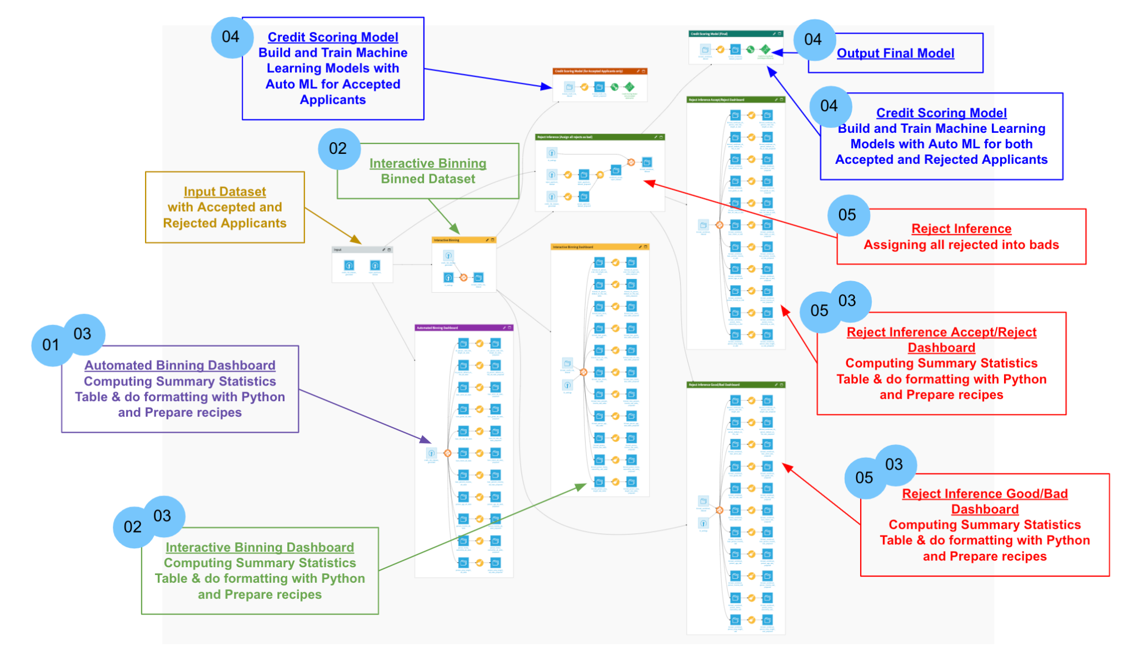

Figure 3.1 Proposed Credit Scoring Model Development Pipeline

**3.5 Data Pre-Processing**

Binning is a data pre-processing technique used to group a larger number of values into a smaller number of bins as mentioned in Section 2.3. As discussed in Chapter 2 Literature Review, automated binning is to be performed for a good initial binning, and interactive binning is to be performed for seeking the optimal binning. In the following sections, the expected results and methodologies of building the automated binning and interactive binning components in the credit scoring model development pipeline are to be presented.

**3.5.1 Automated Binning**

Automated binning, which is the 1st objective of the project, is performed twice within the pipeline proposed according to Section 3.4.

The first time is performed before the interactive binning steps, for providing inputs to the interactive binning interface and generating initial summary statistics and graphs. This binning process is simple. It simply takes every value of an attribute as a single bin, that is, an equal-width binning algorithm with a width equal to 1 is applied.

The second time appears as a feature provided within the interactive binning interface as mentioned in Section 2.7, which allows users to choose between different algorithms, including equal width and equal frequency, to provide the initial binning for human reference. More details will be provided in Section 3.5.2.

**3.5.2 Interactive Binning**

Interactive binning, which is the 2nd objective of the project, is performed within a web application presented in a dashboard (serves as the interactive binning interface) along with the 3rd zone mentioned in Section 3.4 (manipulates the underlying dataset based on manual binning).

**3.5.2.1 Generation of Paid Past Due Column in Dataset**

In credit scoring, binning is performed while monitoring the bins information provided by the summary statistics table. However, to produce table columns such as the counts of good and bad observations in the bins, the definition of good and bad needs to be defined before binning is performed.

According to Spring Milestone, the two common columns used for setting up the criteria for determining whether an observation is good or bad are ‘loan status’, which indicates either loan default (bad) or non-default (good), and ‘paid past due’, which indicates how many days past since the loan due date. However, it does not contain a column providing information related to paid past due in the credit risk dataset collected from Kaggle. Hence, data generation has to be performed for the purpose of building the interactive binning interface.

Based on the recommendation from Sprint Milestone, a column named Paid Past Due is generated by random sampling, within the range of 0-89 days for non-default samples, and within the range of 90-120 days for default samples.

**3.5.2.2 Web App Frameworks for Interactive Binning**

There are 3 main web app frameworks that can be used for building the interactive binning interface: R Shiny, Bokeh, and Dash. In the following sections, the pros and cons of different web app frameworks are introduced, and a comparison is made for determining the frameworks to be used in this project.

**R Shiny:** R Shiny is an open-source package for building web applications with R. It provides a robust web framework for developing any sort of app. Shiny is easy and intuitive to use as it doesn’t require any HTML, CSS, or JavaScript knowledge. Therefore, it can create a better-looking application with less code. It provides interactive charting APIs which suit the purpose of this project. However, for use cases such as obtaining the bar clicked by the user within a bar chart, extra code for the computation of the bar index using the coordinates returned by the APIs is required to be handled by developers. It, hence, could introduce complexity in implementing the binning interface for this project.

**Bokeh:** Bokeh has a much smaller core team, which means that their product is leaner and meaner, with a fairly narrow focus on what the module can and cannot do. But Bokeh is [very well documented](https://bokeh.pydata.org/en/latest/docs/installation.html), which aids developers to move rather quickly to build a basic dashboard with some custom interactive functionality. However, it is slow to bring new features to the code and some bugs can linger for longer than expected.

**Dash Plotly:** Dash Plotly is a Python framework used for building web applications and allows users to express the analysis quickly and visually. It offers the flexibility for engineers to develop extensions for use with their Dash web applications, and provides solid value in the domain of web development for data visualization, including interactive charts. The interactive charting APIs Dash Plotly provides are comprehensive, from getting the coordinates of user clicks to getting the bar or point the user selected within a bar chart of the scatter plot. However, one drawback is that it requires more code and lives mainly in the Python ecosystem only.

**Comparison and Implementation Choice:** After comparing the 3 web app frameworks above, Dash Plotly is chosen as the implementation framework used in this project. This decision is based on 2 criteria, including ease of implementation, and the team’s familiarity with the programming language. Regarding the ease of implementation, as mentioned above, for the use case of getting the bar the user selected within a bar chart, R shiny requires extra computation using the coordinates in the chart while Dash Plotly has already tailor-made APIs for performing the task. Besides, Bokeh, although well documented, the functionalities provided are less comprehensive compared with Dash Plotly. This makes Dash Plotly a better choice for this project. Regarding the team’s familiarity with the programming language, all team members have experience in Python, but only 1 member has experience in R. On these accounts, Dash Plotly is the best choice for the project.

**3.5.2.3 Functionalities and UI Design**

Within the web application presented in the dashboard, includes 4 major functionalities: confirm input dataset, define good and bad definitions, interactive binning, Preview & Download settings. They will be described in detail in the following sections, and the corresponding UI design will also be presented.

**3.5.2.3.1 Confirm Input Dataset**

The home page of the web application to be presented in the Dataiku dashboard displays the input dataset for user reference. Figure 3.2 shows the UI Prototype of the Interactive Binning Interface’s Home Page. This is for the purpose of giving users a glance at what data is contained in the dataset and easing their decision-making in the binning process.

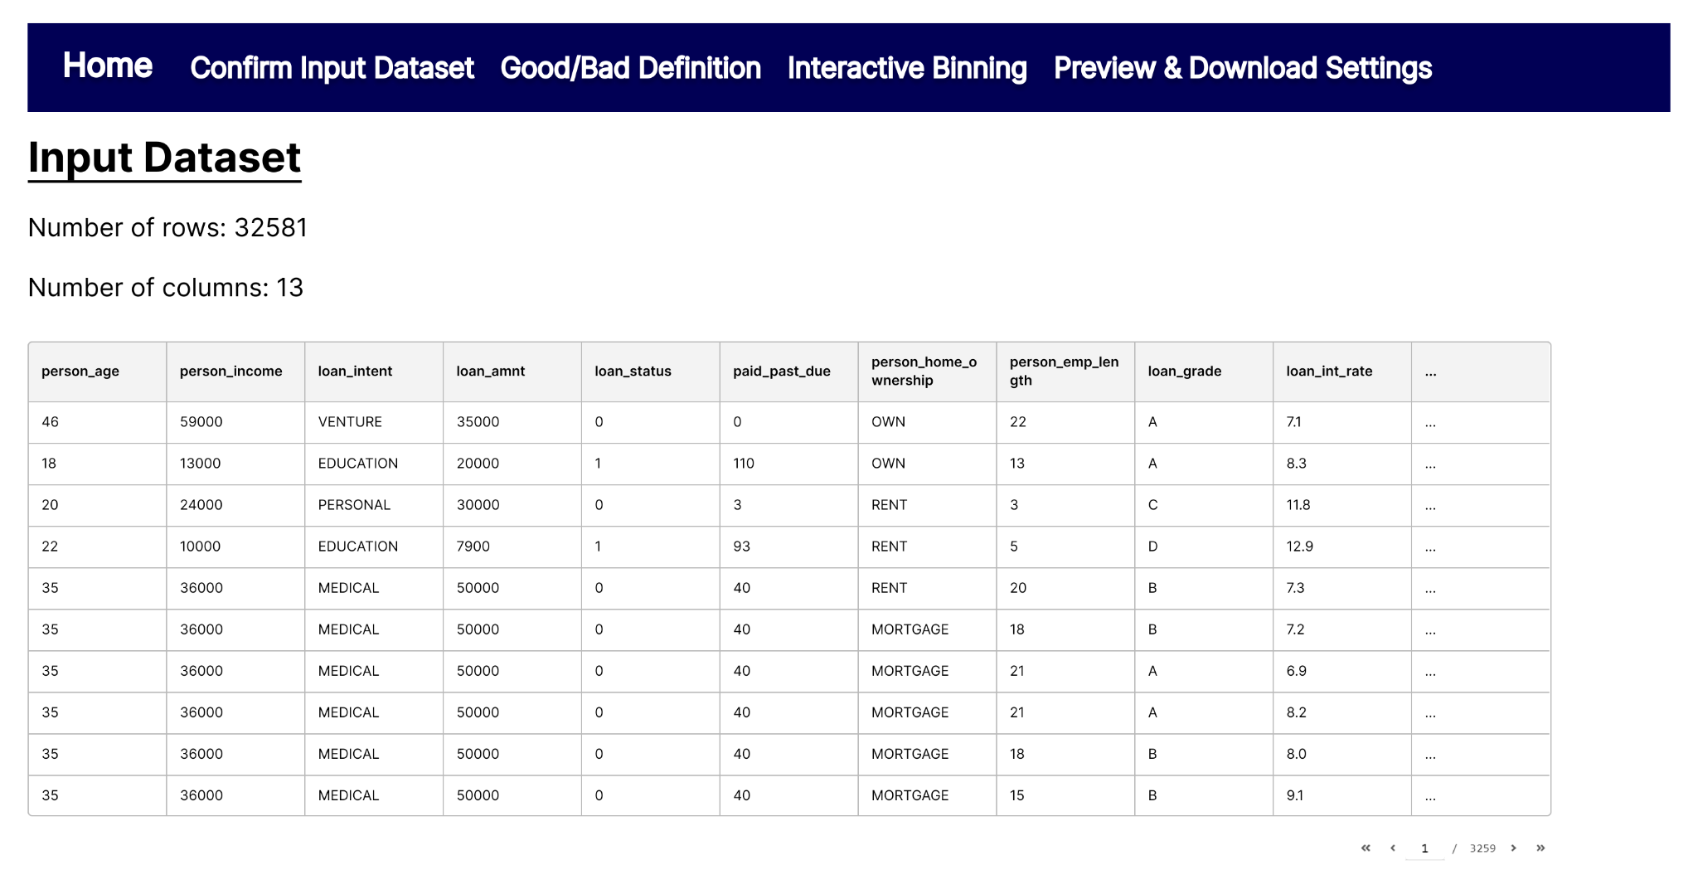

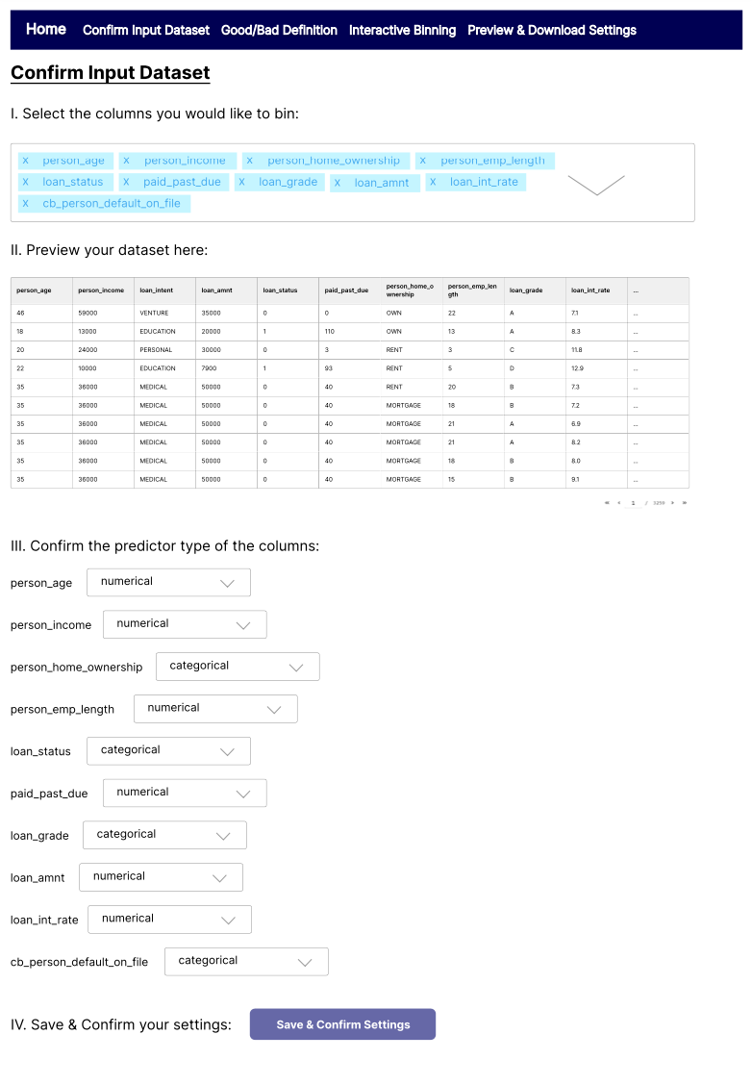

Figure 3.2 UI Prototype of Interactive Binning Interface’s Home Page

**3.5.2.3.2 Define Good and Bad Definition**

As mentioned in Section 3.5.2.1, the interactive binning interface to be built should include features of allowing users to declare the criteria for determining whether an observation is good or bad. It is also mentioned that the 2 common columns used for setting up this criterion are loan status and paid past due. Due to these reasons, the web application has a page specifically designed for defining the good and bad definitions. Figure 3.3 shows the draft UI Prototype of the Interactive Binning Interface’s Good/Bad Definition Page.

First, the user can choose between loan status or paid past due to be used in the definition. Second, if loan status is chosen, a loan status of default indicates the sample as bad, while a loan status of non-default indicates the sample as good. Else, if paid past due is chosen, the user has to divide the data into 3 categories, including good, bad, and indeterminate. The good category represents loans that are very likely to be non-default. The indeterminate category is set up since the loan due date has past and default risk incurred, yet, the loan might still have a chance to be repaid. The bad category represents loan default. The definition of the 3 categories depends on the countries and companies rules and regulations, hence, a slider for users to select the range of indeterminate, ranging from 1 to 120 is given. Given the range of indeterminate, the range for good and bad could be inferred. For paid past due smaller than the lower bound of indeterminate range, the data is categorized as good. On the other hand, for paid past due larger than the upper bound of indeterminate range, the data is categorized as bad.

Since indeterminate data are under uncertainty for whether they belong to the good or bad group, they are then omitted from the dataset. The weights of good data are adjusted from 1 to (count of indeterminate + count of good)/count of good by default as a way used to compensate for the omitted indeterminate data. The weight computed and the bar chart showing the frequency distribution of good and bad is then shown on the page for user reference. Besides, the weight applied on both good and bad data could be adjusted by the user through the interface using the input field. All user inputs, including the column to be used as the good and bad definition criteria, the range of indeterminate, and the weights of good and bad, are only updated when the user presses on the refresh button. The user input is then validated to ensure the weights input is an integer, and within the range of 1 to 120. Otherwise, an error message is to be shown on the interface for warning users.

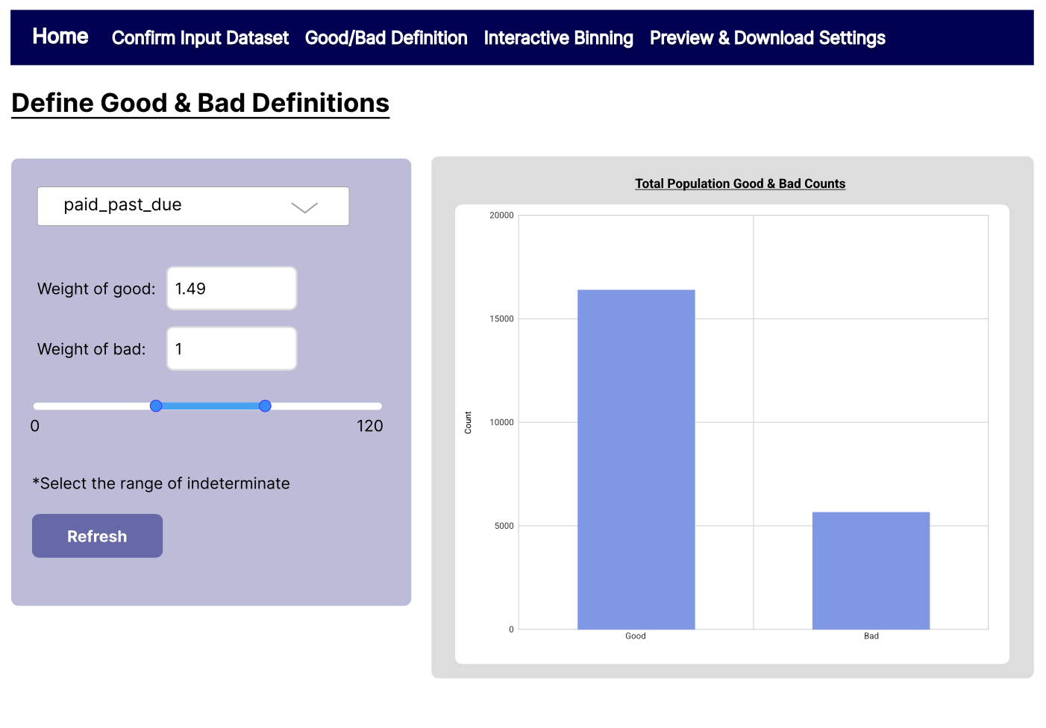

Figure 3.3 Initial UI Prototype of Interactive Binning Interface’s Good/Bad Definition Page

**3.5.2.3.3 Perform Interactive Binning**

As mentioned in Section 3.5.2.3, the core part in the Dash web application is interactive binning. The web application presented in the dashboard has a page specifically designed for performing this task. It includes 6 panels, ‘Select Predictor Variable Panel’, ‘Select Automated Binning Algorithm Panel’, ‘Interactive Chart Panel’, ‘Bin Parameters Control Panel’, ‘Summary Statistics (Before) Panel’, and ‘Summary Statistics (After) Panel’.

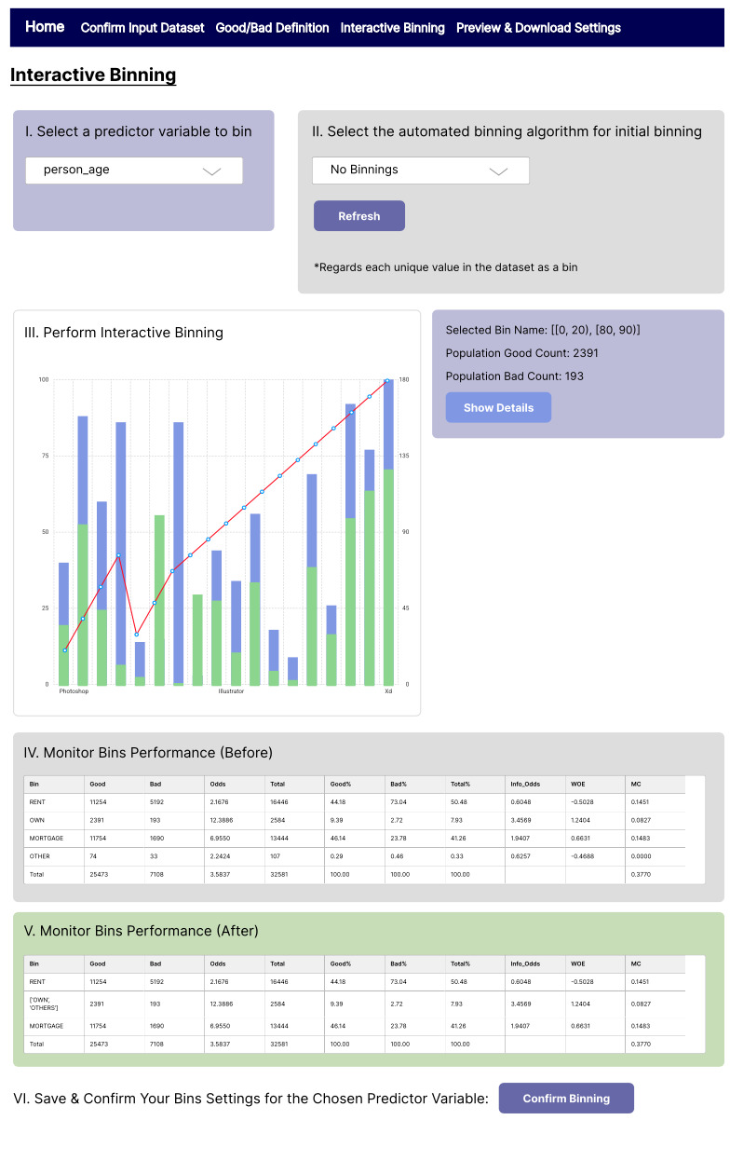

Figure 3.4 Sample UI prototype for Interactive binning Web App

Within the ‘Select Predictor Variable Panel’, the user can choose from a drop down list for which predictor variable to be binned. The drop down list shows the predictor variable names in a descending order of Information Value (IV), which is used to monitor the predictive power of each attribute.



Figure 3.5 UI prototype for ‘Select Predictor Variable Panel’ (Focused)

Within the ‘Select Automated Binning Algorithm Panel’, the user can choose from another drop down list for the automated binning algorithm to be used for the initial binning. There are 3 options, equal width binning algorithm, equal frequency binning algorithm, and no binning. As described in Section 2.3.2, equal width binning algorithm divides the range of values with a predetermined width or into a predetermined number of equal-width bins. Hence, the web application allows users to select either to enter the predetermined width or the predetermined number of equal-width bins for the computation. For the equal frequency binning algorithm, as described in Section 2.3.2, it divides the data with predetermined frequency or into a predetermined number of bins containing approximately the same number of observations. Hence, the web application built for this project allows users to select either to enter the predetermined frequency or the predetermined number of bins containing approximately the same number of observations. The option of “No Binning” is also included in the drop down list, enabling users to compare the before and after result of the existing binning algorithm with the aid of the charts, which will be discussed in the next paragraph. Through clicking on a refresh button, computation on the dataset using the automated binning algorithms is re-performed.

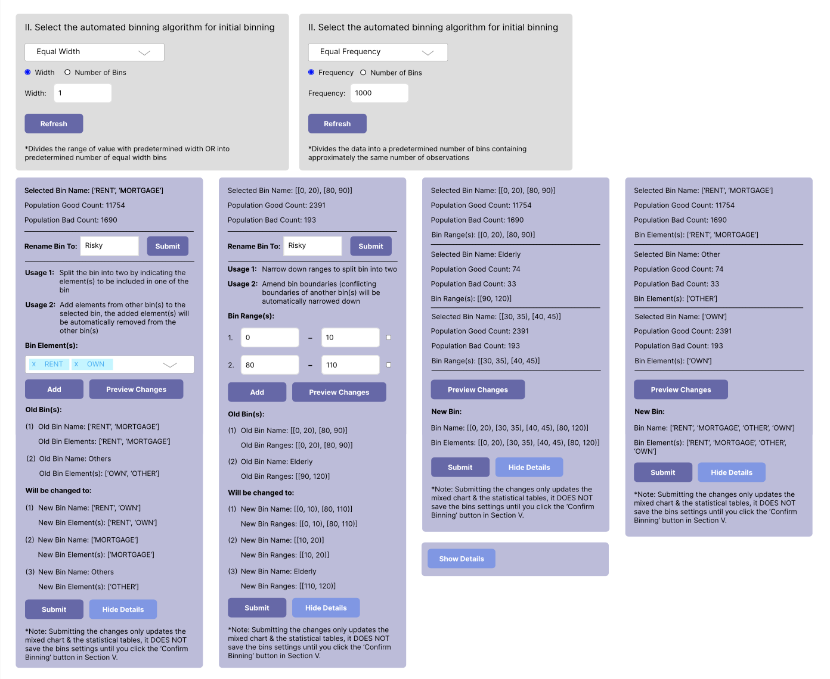

Figure 3.6 Different Alternatives under various commands for automated binning

Within the ‘Interactive Chart Panel’, it mainly consists of a mixed chart. The mixed chart incorporates a bar chart, showing the Good, Bad and Total count of each bin for the selected predictor variable to be binned, and a line chart, indicating the trend of the WOE value for each bin. The frequency distribution can show whether clients with certain characteristics would be more likely to be considered as good or bad. The WOE can show the predictive power of the variable within each bin, and the WOE trend can be observed to evaluate the bins quality since as mentioned in Section 2.3.1, as one of the good binning criteria is a monotone WOE trend. Through showing the two indicators within the same chart, it introduces simplicity and understandability of the visualization dashboard for this project. One of the concerns of using Mixed Chart is that it might be difficult to read the actual WOE number or Good/ Bad Count from the charts, which would be a barrier to the decision making process. Thus, the element of interactive charting is included. Moving the pointer near any bar or point shows the exact number of the corresponding data, aiding users to have an in-depth look into each data group even with substantial amounts of data.



Figure 3.7 Sample Mixed Chart interface based on existing binning (Focused)

Within the ‘Bin Parameters Control Panel’, it incorporates two parts, which are the ‘Bin Information’ and ‘Bin Parameters Adjustments’. If any bar is selected from the graph, a purple box of bin Information including “Selected Bin Name”, “Population Good Count”, “Population Bad Count”.

To proceed to the ‘Bin Parameters Adjustments’ part, users can click the ‘Show Details’ button. This part allows users to perform bin merging and splitting. However, the interface for numerical and categorical variables are different.

Regarding categorical variables, users can perform merging and splitting by clicking one of the bars on the graph and selecting the element from the drop down list. In case elements specified overlap with the other bins from the old bin setting, those elements will be automatically removed from its original bins and those remaining elements that are not specified will be automatically split out as new bins. To better illustrate how the function works, examples would be provided to demonstrate each of the functions. In case user select the bin [‘RENT’, ‘OWN’, ‘MORTGAGE’] for splitting, user could input [‘RENT’] and the system will automatically consider [‘RENT’] as an individual bin, while the remaining element [‘OWN’, ‘MORTGAGE’] would be left as a bin. In case the user select the bin [‘OWN’, ‘MORTGAGE’] for merging, user could input [‘RENT’] and the system will automatically consider [‘RENT’, ‘OWN’, ‘MORTGAGE’] as an individual bin. In a even more complicated case, if user select the bin [‘RENT’, ‘MORTGAGE’], the current two bin settings are [‘RENT’, ‘MORTGAGE’] & [‘OWN’, ‘OTHER’] and the input element are [‘RENT’,‘OWN’], the system will merge the two input [‘RENT’,‘OWN’] as a bin and the remaining elements will be split out into two bins [‘MORTGAGE’]& [‘OTHER’].

Considering that users might want to change the bin’s name for easier identification, the command can also be performed by renaming the newly created bin at the top of the box. When more than one bins are selected, users are then only allowed to merge the selected bins. After clicking the “Merge/Split” button to indicate the changes, users can preview changes. For users’ easy understanding, the preview changes part would show both the original and new Binning Setting, which both include the name or elements of each bin setting, ensuring that the adjustments made are what users expect. After confirming that the changes are right, users could submit the adjustments to update the mixed charts and statistical graph below but noted that submitting the adjustment does not save the binning setting.

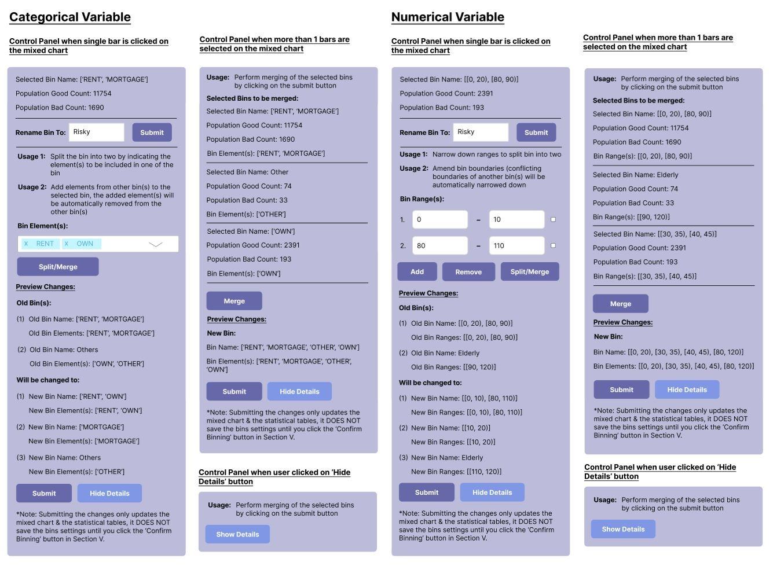

Figure 3.8 Different Bin Adjustment Alternatives under various commands for Categorical Variable

Regarding numerical variables, similar to categorical variables, users can perform merging and splitting by clicking one of the bars on the graph. However, instead of choosing the variables, the range wished to be concluded should be inputted and multiple ranges can also be chosen by clicking the “Add” button. Users have to indicate the range that they wish to remain in the original bin. If range is indicated but does not overlap any range in the old setting, the range indicated will merge with the selected bin. If the range that is indicated but overlapped in the old setting, then the range will then remain the original selected bin. If range is not indicated but is overlapped with any range in the old setting, it will be splitted out as a new bin. In case wrong ranges are chosen, they can still be removed by clicking the box beside them, followed by the “Remove” Button. The remaining procedures, from “Preview Changes”,“Submit” to “Rename Bin”, are also the same as that for categorical variables.

To better illustrate how the function works, the following example is provided. In case the currently selected bin is [[0,20), [80,90)] under age and the two old bin settings are [[0,20), [80,90)] & [[90,120)], users input the two ranges [0,10) and [80,110). As [0,10) & [80,90) are the range that are indicated in the input and overlapped with the current selection, it will remain in the original bin. While [90,110) is the range that are indicated in the input but not overlapped with the current selection, it will merge with the current selection bin. As the remaining bins [10,20) & [20,80) are not indicated and overlap with the old bin setting, each of the ranges will be splitted into an individual bin. As a result, the system will consider [[0,10), [80,110)] as a replacement of the original bin and split the remaining ranges [10,20) & [20,80) into two new bins.

Similar to categorical variables, when the user clicks the “Box Select '' and selects more than one of the bars, only “Merge'' function will show up in the box. After confirming that the bin setting is right with preview changes function, users could submit the adjustments to further update the mix charts or statistical table.



Figure 3.9 Different Bin Adjustment Alternatives under various commands for Numerical Variable

Within the ‘Summary Statistics (Before) Panel’, and ‘Summary Statistics (After) Panel’, users can compare the summary statistics table, in which its detail explanation should refer to Section 3.5.3.1, of the existing bin setting (i.e.: After) and the bin setting since last changes. Through comparing summary statistics, users can determine whether the existing bin setting is better than the previous one, thus deciding whether it should be saved for later use.

Figure 3.10 Sample interface for the Summary Statistics Panel (Focused)

**3.5.2.3.4 Binning Preview & Summary**

After manual binning has been performed, users can preview the binned dataset, summary statistics tables, and mixed charts showing the frequency distributions of bins and WOE trend for each predictor variable. Figure 3.5 shows the UI Prototype of Interactive Binning Interface’s Preview and the Summary Page.

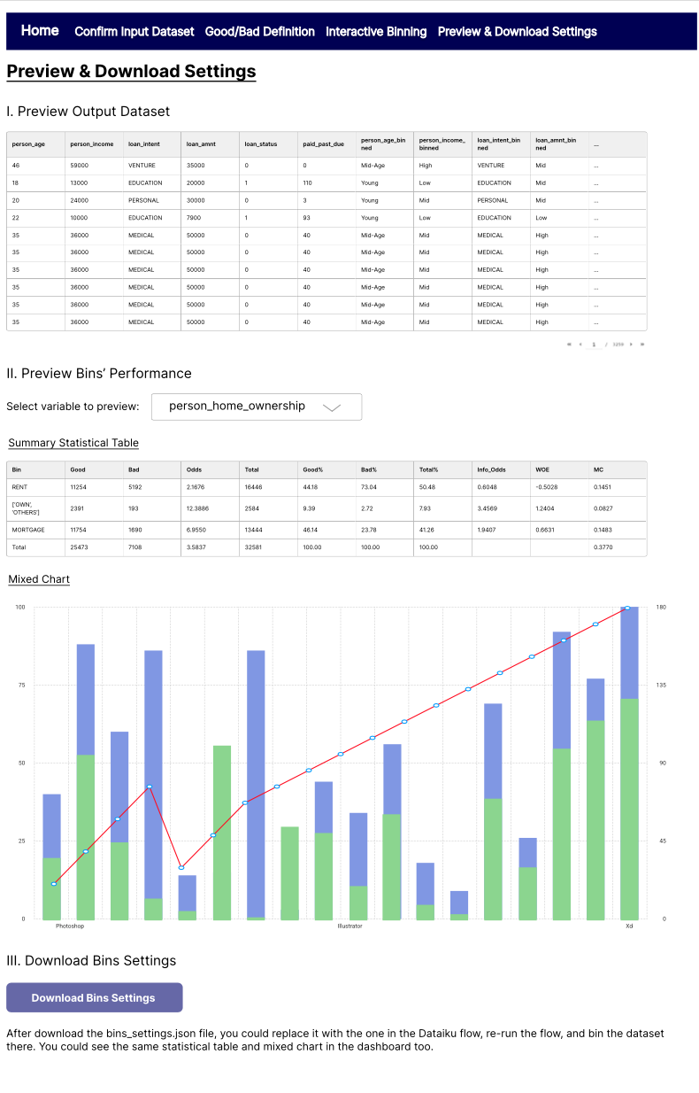

Figure 3.11 UI Prototype of Interactive Binning Interface’s Preview & Summary Page

**3.5.2.3.5 Save Bins Settings**

Once the user is satisfied with the binning, the bins settings could be downloaded through pressing the save bins settings button in Figure 3.5. The user can obtain the JSON file containing the boundary points of all bins for each predictor variable, and the file can be uploaded to the Interactive Binning zone mentioned in Section 3.4 for manipulating the underlying dataset in Dataiku based on the manual binning. Furthermore, this JSON file can be imported to the interactive binning interface again as mentioned in Section 3.5.2.3.3 to update the binnings of attributes.

**3.5.2.4 Dash Web Application**

As mentioned in Section 3.5.2.2, Dash Plotly will be used as the web app framework for the interactive binning when compared with Shiny and Bokeh. Dash is a low-code framework for rapidly building and deploying data apps with custom user interfaces in Python. It abstracts away all of the technologies and protocols that are required to build a full-stack web application with interactive data visualization (Plotly ,N.A.). Dash is an open-source library, and is available for use in the Dataiku web app tools. It enables interactive charts, for example, allows developers to get the coordinates of the point user clicked on the chart, and perform actions in response to that.

**3.5.2.5 Python Recipe**

As mentioned in Section 3.4 and in Figure 3.1, a Python recipe is used for manipulating the underlying credit risk dataset in Dataiku based on the bin settings obtained from the web application built. It takes the credit risk dataset and the bin settings dataset (obtained from the web application page mentioned Section 3.5.2.3.5) as input, using the boundary points for all bins described in the bin settings, performs computation and updates the credit risk dataset with new bins. The output dataset contains the same number of attributes as the input dataset, but the data nature is all categorical. It could then be used as the training dataset for the credit scoring model which will be discussed in Section 3.6, and could be used to create summary statistics and charts for the project’s 3rd objective, the visualization dashboard.

**3.5.3 Visualization Dashboard**

As mentioned in Section 1.4, the 3rd objective of the project is to construct visualization dashboards for monitoring binning performance. In total, 2 visualization dashboards are to be built, one for automated binning, and the other for interactive binning. The automated binning dashboard is implemented in the Automated Binning Dashboard zone as mentioned in Section 3.4 and in Figure 3.1. The interactive binning dashboard, on the other hand, is implemented in the Interactive Binning Dashboard zone also mentioned in Section 3.4 and in Figure 3.1. The pipeline structure for both zones is exactly the same, therefore, the following sections discussing the expected results and methodologies are for both of them.

A visualization dashboard is implemented through the use of a Python recipe for computing the summary statistics, Prepare recipes for formatting the values, Charts for creating mixed charts from the dataset, and Dashboard for sharing the computed results and the created charts in a centralized location. In the following sections, a detailed description on the content of summary statistics and charts is introduced, and the methodologies used for implementing the dashboard is also presented.

**3.5.3.1 Summary Statistics Table**

Summary statistics table is useful for providing statistical information of predictor variables and indicating the predictive power of them. The user of the credit scoring model development pipeline, that is, the credit scoring professionals could then make use of this summary statistics table to evaluate the bins quality and aid decision making for further binning. For example, the bins with high WOE indicate high predictive powers, while bins with similar WOE values could be merged to improve bins quality. Table 3.2 shows the information included in the summary statistics table:

| **Index** | **Column** | **Format** | **Definition** |
| --- | --- | --- | --- |
| 1 | Bin | String | Bin’s name |
| 2 | Good | Integer | Count of ‘0’ in ‘loan_status’ column within each bin |
| 3 | Bad | Integer | Count of ‘1’ in ‘loan_status’ column within each bin |
| 4 | Odds | Float  (4 d.p.) | $\frac{Good}{Bad}$ |
| 5 | Total | Integer | Count of observations within each bin |
| 6 | Good% | Float  (2 d.p.) | $\frac{Good}{Total Good}$ $×100\%$ |
| 7 | Bad% | Float  (2 d.p.) | $\frac{Bad}{Total Bad}$ $×100\%$ |
| 8 | Total% | Float  (2 d.p.) | $\frac{Total}{Count of observations in the whole dataset}$ $×100\%$ |
| 9 | Info_Odds | Float  (4 d.p.) | $\frac{Good \%}{Bad \%}$ |
| 10 | WOE | Float  (4 d.p.) | $ln(Info_Odds)$ |
| 11 | MC | Float  (4 d.p.) | $(Good\% - Bad\%)×WOE$ |

Table 3.2 Summary Statistics Table Column Names and Definitions

(1) Bin - A string providing a unique name for a bin.

(2) Good - An integer indicating the total number of borrowers who have not defaulted on the loan within each bin, which is calculated by counting the number of observations with a value 0 (non-default) in the ‘loan_status’ column within each bin.

(3) Bad - An integer indicating the total number of borrowers who have defaulted on the loan within each bin, which is calculated by counting the number of observations with a value 1 (default) in the ‘loan_status’ column within each bin.

(4) Odds - A float rounded to 4 decimal points used for measuring the likelihood of ‘good’ to happen as an outcome (Psychscene Hub, N.A.), which is calculated by dividing good over bad. The higher the odds, the more likely the loan will not default.

(5) Total - An integer indicating the total number of observations in each bin.

(6) Good% - A float rounded to 2 decimal points representing the percentage of the number of goods within each bin over the total number of goods for the whole dataset. It can reflect the proportion of the borrowers who pay their bills on time within a bin when compared to the total dataset of customers who pay their debt within the time limit.

(7) Bad% - A float rounded to 2 decimal points representing the percentage of the number of bads within each bin over the total number of bads for the whole dataset. It can reflect the proportion of the borrowers who are unable to pay their bills on time inside a bin when compared to the total dataset of customers who are unable to pay their debt within the time limit.

(8) Total% - A float rounded to 2 decimal points representing the total number of records of each bin over the whole dataset. It is useful in understanding the distribution of each bin within the dataset.

(9) Information Odds (Info_Odds) - A float rounded to 4 decimal points used as an intermediate value for computation of the Weight of Evidence, which is calculated by dividing the good percentage over the bad percentage.

(10) Weight of Evidence (WOE) - A float rounded to 4 decimal points showing the predictive power of an independent variable in relation to the dependent variable (Deepanshu, N.A.). In other words, it can measure the strength of the predictor variable of each bin in prediction. It is calculated by taking the natural logarithm of the Information Odds.

(11) Marginal Contribution (MC) - A float rounded to 4 decimal points, useful in evaluating the predictive power of the variable by assisting the calculation of Information Value (IV). Marginal cost is calculated by multiplying WOE with the difference between good percentage and bad percentage.

Besides, the last row of the summary statistics, which is shown in Figure 3.12, behave differently with the other parts of the table. While the body of the summary statistics table provides statistical information of all bins for a particular predictor variable, the last row provides the total of all bins.

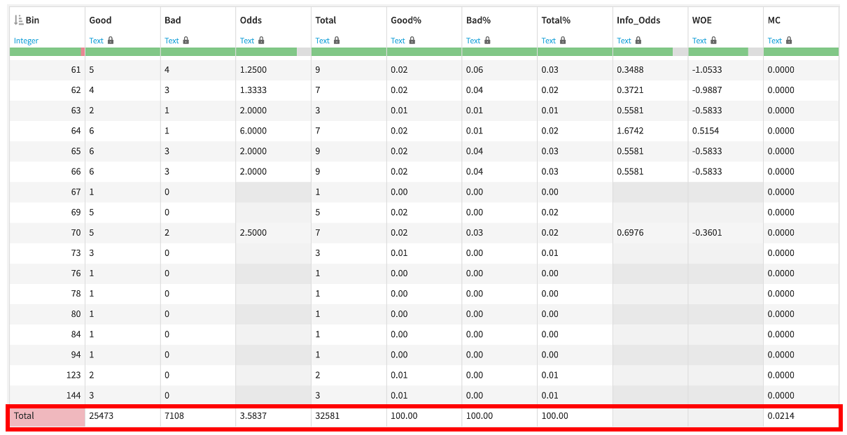

Figure 3.12 Last Row of Summary Statistics Table

Table 3.3 and Table 3.4 shows the information included in the last row of the summary statistics table:

| **Index** | **Column** | **Format** | **Definition** |
| --- | --- | --- | --- |
| 1 | Bin | String | A String printing “Total” |
| 2 | Good | Integer | Count of ‘0’ in ‘loan_status’ column within the whole dataset |
| 3 | Bad | Integer | Count of ‘1’ in ‘loan_status’ column within the whole dataset |
| 4 | Odds | Float (4 d.p.) | $\frac{Good}{Bad}$ |
| 5 | Total | Integer | Count of observations within the whole dataset |
| 6 | Good% | Float (2 d.p.) | 100% |
| 7 | Bad% | Float (2 d.p.) | 100% |
| 8 | Total% | Float (2 d.p.) | 100% |
| 9 | Info_Odds | Float (4 d.p.) | None |
| 10 | WOE | Float (4 d.p.) | None |
| 11 | MC | Float (4 d.p.) | $Information Value (IV) =\sum_{all bins}{}MC$ |

Table 3.3 Summary Statistics Table Column Names and the Definitions the Last Row

(1) Bin - A string named ‘Total’ indicating the different behaviour of this row.

(2) Good - An integer indicating the total number of borrowers who have not defaulted on the loan within the whole dataset, which is calculated by counting the number of observations with a value 0 (non-default) in the ‘loan_status’ column for the whole dataset.

(3) Bad - An integer indicating the total number of borrowers who have defaulted on the loan within the whole dataset, which is calculated by counting the number of observations with a value 1 (default) in the ‘loan_status’ column for the whole dataset.

(4) Odds - Similar to the computation of odds within each bin, it is a float rounded to 4 decimal points, calculated by dividing good over bad.

(5) Total - An integer indicating the total number of observations in the whole dataset.

(6) Good% - A float rounded to 2 decimal points, calculated by summing up all good percentages of bins, which is equal to 100%.

(7) Bad% - A float rounded to 2 decimal points, calculated by summing up all bad percentages of bins, which is equal to 100%.

(8) Total% - A float rounded to 2 decimal points, calculated by summing up all total percentages of bins, which is equal to 100%.

(9) Information Odds (Info_Odds) - Since no WOE value has to be computed by definition, it is represented as None, and is blanked in the summary statistics table.

(10) Weight of Evidence (WOE) - Since no WOE value has to be computed by definition, it is represented as None, and is blanked in the summary statistics table.

(11) Marginal Contribution (MC) - A float rounded to 4 decimal points, which is the sum of MC of all bins for a predictor variable representing the Information Value (IV). This measure provides information about the predictive power of the predictor variable. The higher the information value, the more predictive the variable is. (SAS Help Center, N.A.) The following table shows the correlation between IV and the predictive power of the variable:

| **Information Value (IV)** | **Predictive Power** |
| --- | --- |
| < 0.02 | Useless |
| 0.02 - 0.1 | Weak |
| 0.1 - 0.3 | Medium |
| 0.3 - 0.5 | Strong |
| > 0.5 | Suspiciously good; too good to be true |

Table 3.4 Predictive power of the information value (Siddiqi, 2006)

**3.5.3.2 Mixed Chart**

A mixed chart incorporates a bar chart, showing the frequency distribution of the bins for a particular predictor variable, and a line chart, indicating the trend of the WOE value for each bins. Figure 3.7 shows an example of a mixed chart. The WOE can show the predictive power of the variable within each bin, and the WOE trend can be observed to evaluate the bins quality since as mentioned in Section 2.3.1, one of the good binning criteria is a monotone WOE trend. Through showing the two indicators within the same chart, it introduces simplicity and understandability of the visualization dashboard for this project.

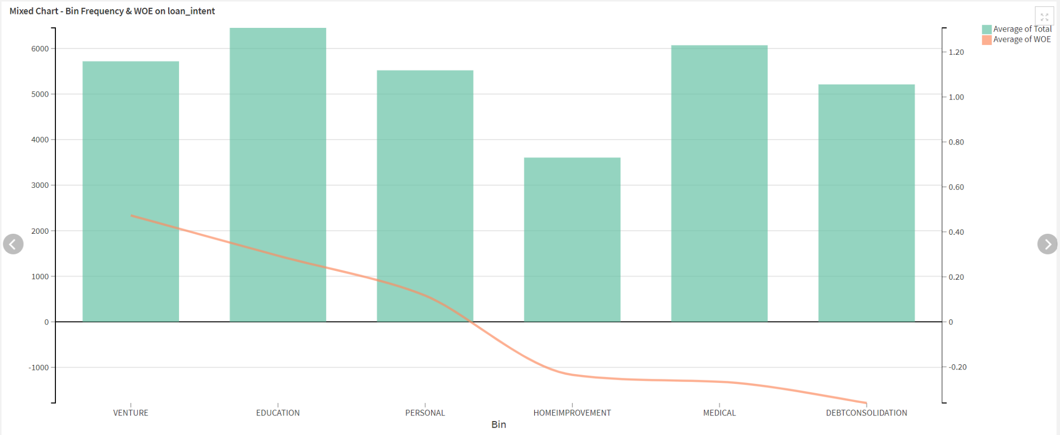

Figure 3.11 An Example of a Mixed Chart

**3.5.3.3 Python Recipe**

A Python recipe taking the binned dataset as input is used for computing the summary statistics table mentioned in Section 3.5.3.1. It loops through all the predictor variables in the dataset and generates the corresponding summary statistics datasets as the output. The Python recipe implements separate functions for calculating different summary statistics such as good, bad, odds, etc.. It also uses separate functions for computing the bins statistics versus the total statistics in the last row of the table.

**3.5.3.4 Prepare Recipe**

11 Prepare recipes (one for each column of the summary statistics table) are used for formatting the values in the table according to Table 3.3 and Table 3.4. For example, WOE and MC are rounded to 4 decimal places, while Good%, Bad%, and Total% are rounded to 2 decimal places.

**3.5.3.5 Charts**

The mixed charts mentioned in Section 3.5.3.2 is created using the graphical interface as described in Section 3.3.5. They are embedded in the dataset, and are included in the dashboard which will be discussed in the next section.

**3.5.3.6 Dashboard**

A visualization dashboard contains 11 sheets, one for each predictor variable in the credit risk dataset. Among each sheet, a summary statistics table, as described in Section 3.5.3.1, and a mixed chart, as described in Section 3.5.3.2, is presented for providing statistical and visual information of bins to the credit scoring professionals to monitor bins quality and assist them in decision making on further bins adjustments.

**3.6 Credit Scoring Model Development - Auto Machine Learning**

As mentioned in Section 3.3.4, Dataiku provides automated machine learning solutions for developers. The Credit Scoring Model zone described in Section 3.4 utilizes this Auto ML capability of Dataiku. The interactively binned dataset obtained from the Interactive Binning zone, that is, the output of the Python recipe mentioned in Section 3.5.2.5, would be the training dataset used for building the credit scoring model. A Visual Analyses environment in Dataiku for monitoring models training is to be implemented in this project. Any models could be trained in this environment using the Dataiku tools. By default, as mentioned in Section 2.7, Logistic Regression, Decision Tree, Random Forest, Support Vector Machine (SVM), Gradient Tree Boosting, XGBoost and Neural Network are included. Users of the pipeline, that is, the credit scoring professionals, could adjust the design of the model training, for example, adjusting the algorithms to be trained, hyperparameters settings, incorporating custom Python models, etc. After training, model reports are generated, providing information such as variables with highest predictive power, optimal hyperparameters after hyperparameters search, etc. The best model among all the trained models is indicated with a trophy icon next to the model’s name. It could then be deployed and update the Dataiku flow and be used for further processing with reject inference.

**3.7 Reject Inference**

Most of the credit risk models are built based on the behaviour of the accepted applicants. However, the characteristics of rejected applicants are not taken under consideration, forming a bias towards certain attributes. Thus, reject inference is a prevalent technique introduced to incorporate characteristics of rejected applicants into the credit scoring process, aiming to reduce the bias and induce an expansion of the potential clients size.

For example, financial institutions will most likely reject applicants aged above 60 and with liability, as they will retire soon and may not have a stable income source in near future. With liability, their ability to repay debt is in doubt. However, if the applicants with such attributes are still approved, they must have other qualities like a huge asset or good credit history that assured the bank to lend them money, thus these applicants will most likely end up with a low default rate. As a result, this group of applicants are labelled as “Good” when applying the model to the whole applicant population, forming an inaccurate conclusion. With the use of the reject inference technique, the model can incorporate characteristics of rejected applicants and form a more accurate decision.

As mentioned in Section 2.6, there are various reject inference approaches, for example, assigning all rejects to bad and augmentation. Based on these examples, the team proposed 3 methods and developed a detailed acting plan for each of them.

**3.7.1 Method 1: Assigning all Rejects to Bad**

Method 1 would be assigning all the rejected applicants to Bad. As the rejected population are usually those who are riskier lending money to, applicants with similar characteristics could also be assumed to result in a lower credit score, thus assigning them all to bad would be a conservative way to perform reject inference. The detailed steps of performing reject inference would be as following:

1. Generate dummy reject application dataset which has the same attributes as the accept application dataset. For each of the attributes, a random number or category is assigned to them. To perform a better simulation on the rejected population, upper and lower boundaries are set for numerical attributes based on the distributions from the accepted population. Moreover, as this population is assumed to be rejected from their credit application, their record should not contain any loan-performance related indicator (i.e.: “loan status” & “paid past due”). Thus, these two attributes are excluded when recreating the dataset based on the accepted dataset.
2. Perform data preprocessing on both reject and accept dataset to prepare for dataset combination in later stage. To identify the reject population from the whole, a column named “accept_reject_status” is created, where all accept data is assigned to 0 (i.e.: accepted) and reject data is assigned to 1 (i.e.: rejected). Moreover, as Method 1 is to assign all reject data to bad, “loan status” is created for the reject dataset and all the rejected data is assigned to 1 (i.e.: default).
3. Combine the two dataset (i.e.: accepted and rejected dataset). Through combining the two datasets, the combined dataset can be used as one training dataset to train the new credit scoring model with the feature of reject inference.
4. Bin the combined dataset with the same bin setting from the accepted dataset or re-perform binning procedure in the web app.
5. Compute summary statistic tables to calculate WOE of each performance outcome (i.e.: Accept/Reject and Good/Bad). Each attribute will result in a similar table as following:

| Bin | **Data from both dataset** | | | | | | **Data from both dataset** | | | | | |
| --- | --- | --- | --- | --- | --- | --- | --- | --- | --- | --- | --- | --- |
| Good | Bad | G/B Odds | Info_Odds | G/B WOE | G/B MC | Accept | Reject | A/R Odds | Info_Odds | A/R WOE | A/R  MC |
| OWN | 2391 | 193 | 12.3886 | 371.14% | 1.31142 | 0.099243909 | 2391 | 193 | 12.3886 | 371.14% | 1.31142 | 0.099243909 |
| MORTGAGE | 11754 | 1690 | 6.9550 | 208.36% | 0.73410 | 0.194414284 | 11754 | 1690 | 6.9550 | 208.36% | 0.73410 | 0.194414284 |
| OTHER | 74 | 33 | 2.2424 | 67.18% | -0.39780 | 0.000623067 | 74 | 33 | 2.2424 | 67.18% | -0.39780 | 0.000623067 |
| RENT | 11254 | 5192 | 2.1676 | 64.94% | -0.43176 | 0.113666305 | 11254 | 5192 | 2.1676 | 64.94% | -0.43176 | 0.113666305 |
|  |  |  |  |  |  |  |  |  |  |  |  |  |
| Total | 23082 | 6915 | 11.3650 | 7.1162 | 1.2160 | 0.4079 | 23082 | 6915 | 11.3650 | 7.1162 | 1.2160 | 0.4079 |

With the above summary statistics table, the user could have a better overview on the frequency distribution of Good/ Bad and Accept/ Reject, as well as the WOE trend, aiding the user to understand the data better and preferably provide insight on the binning performance.

1. After reviewing the summary statistic, the interactive binning process can be re-performed and the best bin setting should be saved. Bin the combined dataset based on saved bin settings. The dataset with corresponding binning is then imported to build the final credit scoring model.

**3.7.2 Method 2: Auto Machine Learning**

Assigning all rejects to bad may be a conservative method, however it does not try to infer the actual label for the reject population, or reach the aim in expanding the serve population. Among all the approaches mentioned in Section 2.6, Auto Machine Learning (Auto ML) is a technique based on Simple Augmentation. This method computes a credit score for each entry of the reject population and the entry will be assigned to Bad if it is below a user-specified threshold. Since scores are computed for the reject population based on the model built in the previous stage, it is possible that some of the reject population are considered to be Good, thus more sophisticated inference is conducted and the aim of expanding the serve population is fulfilled. The detailed steps of performing reject inference would be as following:

1. Generate dummy reject application dataset as mentioned in Method 1 Step 1.
2. By making use of the accepted dataset as a training dataset, a logistic regression model can be trained to predict the probabilities of being good or bad of each entry within the reject dataset. The probabilities of being good at each entry can be considered as its credit score.
3. Append a column “loan_status” for the reject dataset and label each entry. A threshold, which could be the accept/reject odds or any other user-specified threshold, should be determined for data assignment. In any way, data is assigned to 1 (i.e.: default) if its credit score is below the threshold.
4. Create another column “accept_reject_status” for both dataset and label each entry. To identify the reject population from the whole, a column named “accept_reject_status” is created, where data from accept dataset is assigned to 0 (i.e.: accepted) and data from the reject dataset is assigned to 1 (i.e.: rejected).
5. Combine the two dataset to obtain a new dataset.
6. Bin the combined dataset using the same bin setting from interactive binning of the accepted dataset.
7. Compute summary statistic tables to calculate WOE of each performance outcome (i.e.: Accept/Reject and Good/Bad) as mentioned in Method 1 Step 5.
8. After reviewing the summary statistic, the interactive binning process can be re-performed and the best bin setting should be saved. Bin the combined dataset based on saved bin setting. The dataset with corresponding binning is then imported to build the final credit scoring model.

**3.7.3 Method 3: Naive Bayes**

Similar to Method 2, Naive Bayes is a technique based on Simple Augmentation. This method computes the probability of being good or bad for each entry of the reject population based on the data from the accepted dataset as well. The major difference is that the label assignment depends on which probability is greater. The detailed steps of performing reject inference would be as following:

1. Generate dummy reject application dataset as mentioned in Method 1 Step 1.
2. Create another column “accept_reject_status” for both dataset and label each entry as mentioned in Method 2 step 5.
3. Combine the two dataset to obtain a new dataset.
4. Bin the combined dataset using the same bin setting from interactive binning of the accepted dataset. As the summary statistic table that will be computed in Step 5 will compare the statistic from the accepted dataset and combined dataset side by side, the combined dataset should be binned with the same setting as in the accepted dataset.
5. Compute summary statistic tables to calculate odds of each performance outcome (i.e.: Accept/Reject and Good/Bad). Each attribute will result in a table as following:

| Bin | **Data from accepted dataset only** | | | **Data from both dataset** | | |
| --- | --- | --- | --- | --- | --- | --- |
| Good | Bad | G/B Odds | Accept | Reject | A/R Odds |
| OWN | 2391 | 193 | 12.3886 | 2391 | 193 | 12.3886 |
| MORTGAGE | 11754 | 1690 | 6.9550 | 11754 | 1690 | 6.9550 |
| OTHER | 74 | 33 | 2.2424 | 74 | 33 | 2.2424 |
| RENT | 11254 | 5192 | 2.1676 | 11254 | 5192 | 2.1676 |
|  |  |  |  |  |  |  |
| Total | 23082 | 6915 | 11.3650 | 23082 | 6915 | 11.3650 |

1. Append a column “loan_status” for the reject dataset and label each entry based on the Naive Bayes rule. Conditional probability of belonging to a certain attribute class given that it is good or bad can be computed through the G/B odds data. Take the G/B odds of “OWN” bin from the above table as an example, it implies that there are 12.3886 good applicants for each bad applicant, thus:

The conditional probability of owning a house given that it is a bad applicant

$=\frac{1}{(1+12.3886)}=0.07469$

The conditional probability of owning a house given that it is a good applicant

$=\frac{12.3886}{(1+12.3886)}=0.09253$

Generalizing the result from the above example, the formula for conditional probability of belonging to that attribute class given that it is good or bad can be computed with the following formula:

$P(attribu{te}_{1}^{}=Y_{1}|Bad) = \frac{1}{(1+G/B odds)}$

$P(attribu{te}_{1}^{}=Y_{1}|Good) = \frac{G/B odds}{(1+G/B odds)}$

Based on the naive Bayes rule, the conditional probability of an entry $X_{1}$ given that it is bad can be obtained after multiplying all the conditional probabilities of a certain class from $n$ attributes, which could be explained in the following formula:

$P(entry= X_{1}|Bad) =P(attribu{te}_{1}^{}= Y_{1}|Bad)×P(attribu{te}_{2}^{}= Y_{1}|Bad)×...$ $×P(attribu{te}_{n}^{}= Y_{1}|Bad)$

The conditional probability of an entry $X_{1}$ given that it is good can also be computed in a similar way.

After that, each conditional probability can be multiplied with the probability of being good or the probability of being bad to obtain the final probabilities as shown in the following:

$Final probability of X_{1}being Good=P(entry= X_{1}|Good)P(Good)$

$Final probability of X_{1}being Bad=P(entry= X_{1}|Bad)P(Bad)$

After computing this set of probabilities in each entry from the reject dataset, label of 1 (i.e.: default) is assigned if the probability of being bad is higher, otherwise, label of 0 (i.e.: non-default) is assigned.

1. Compute summary statistic tables again to calculate WOE of each performance outcome (i.e.: Accept/Reject and Good/Bad). Each attribute will result in a table as shown in Method 1 Step 5.
2. After reviewing the summary statistic, the interactive binning process can be re-performed and the best bin setting should be saved. Bin the combined dataset based on saved bin settings. The dataset with corresponding binning is then imported to build the final credit scoring model.

**3.7.4 Reject Inference Implementation**

Despite the fact that there are multiple possible ways in performing reject inference,

the team only adopted Method 1 in our pipeline due to its conservative nature, which is the risk culture of many financial institutions, and project time limitation.

**3.8 Summary**

The credit scoring model development pipeline is to be delivered as a Dataiku project. It incorporates a flow comprising 5 zones, namely Input zone, Automated Binning Dashboard zone, Interactive Binning zone, Interactive Binning Dashboard zone, and Credit Scoring Model zone. Part of the interactive binning interface and the automated reject inference solution is not included in this chapter due to time limitations, more research is needed for designing the methodology used for it. Besides the flow, the Dataiku project also includes a Dash web application for performing interactive binning. It uses Python as the programming language, and allows users to perform manual binning and download the bins settings in JSON format. The bins settings could then be uploaded into the flow for manipulation using a Python recipe. Furthermore, 2 visualization dashboards, one for automated binning, and another for interactive binning are included as the deliverables. The dashboards are for monitoring the bins quality before and after the binning is performed. Finally, a Visual Analyses environment is also included for allowing training and fine-tuning of credit scoring models. It provides huge flexibility for model training, and generates automated reports on the model design, training process, and performance. Users could update the model in the flow after training in this Visual Analyses environment, and it would then be used for performing reject inference later.

**4. Implementation**

The entire credit scoring model pipeline comprises five components, including automated binning, interactive binning, visualization dashboard, credit scoring model, and automated reject inference solution, which detailed methodologies of each component of the pipeline are illustrated in Chapter 3. Most of the components are built following the methodologies the team proposed previously and the results are the same as their expected outcome. However, during the implementation of the interactive binning part, adjustments are made based on the previous prototype for better functionality and user experience. Thus, this chapter will first illustrate and explain each adjustment in detail, then showcase each component of the entire credit scoring model pipeline for a better understanding on the final project flow.

**4.1 Automated Binning**

As described in Section 3.5.1, automated binning is performed twice within the pipeline proposed. Among the two, the project team has currently completed the first automated binning, which is performed before the interactive binning steps, for providing inputs to the interactive binning interface and generating initial summary statistics tables and charts. It is presented in the Input zone in Figure 4.1, which is also the initial credit risk dataset input to the pipeline. Every value of a predictor variable is taken as a single bin, that is, an equal width binning algorithm with width equals to 1 is applied. (can delete)

**4.2 Adjustment in Interactive Binning**

The prototype of Interactive Binning has been completed as shown in Section 3.5.2.3. However, after several discussions with our business partners, several suggestions are provided regarding our previous web application and interactive binning interface to further introduce flexibility to our users.

In our web application system, it still contains the same series of steps, which is “Confirm Input Dataset”, “Good/ Bad Definition”, “Interactive Binning” and “Preview & Download Settings”. Adjustments are made in the details of the interfaces as shown in the following:

**4.2.1 Adjustments in “Confirm Input Dataset” Interface**

In Section 3.5.2.3.1, “Confirm Input Dataset” Interface is mainly used as an interface displaying the input dataset for user reference, giving the user a last glance of the data before the binning process. There are now two new functions included.

In order to further increase flexibility of the binning process, users are allowed to drop off the columns they do not wish to include in “Confirm Input Dataset” Interface, which remove unnecessary information to be shown in the binning process and may aid the accuracy of the model by eliminating irrelevant attributes manually.

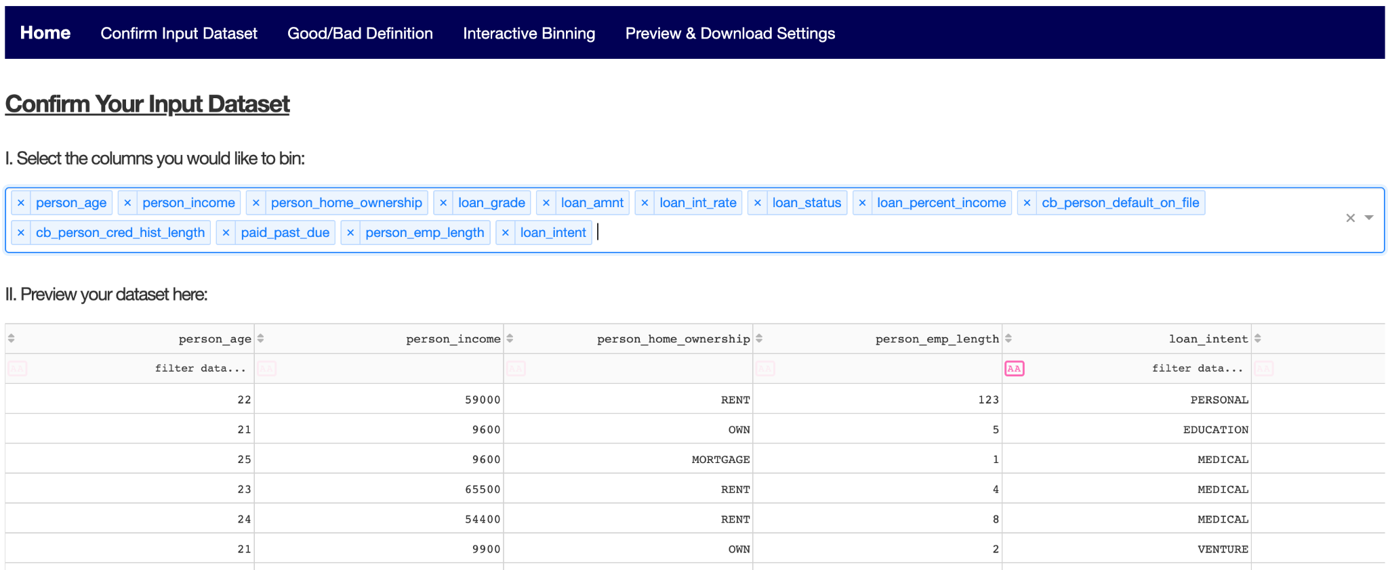

Another new add-ons is that users have to confirm the predictor type of the columns. For the attributes chosen in the previous part, users are requested to choose either “numerical” or “categorical” for each of them. It aims to provide a more accurate and efficient processing of data in later parts. After that, users can click the button to save the settings and move on to the next page for “Good/ Bad Definition”.

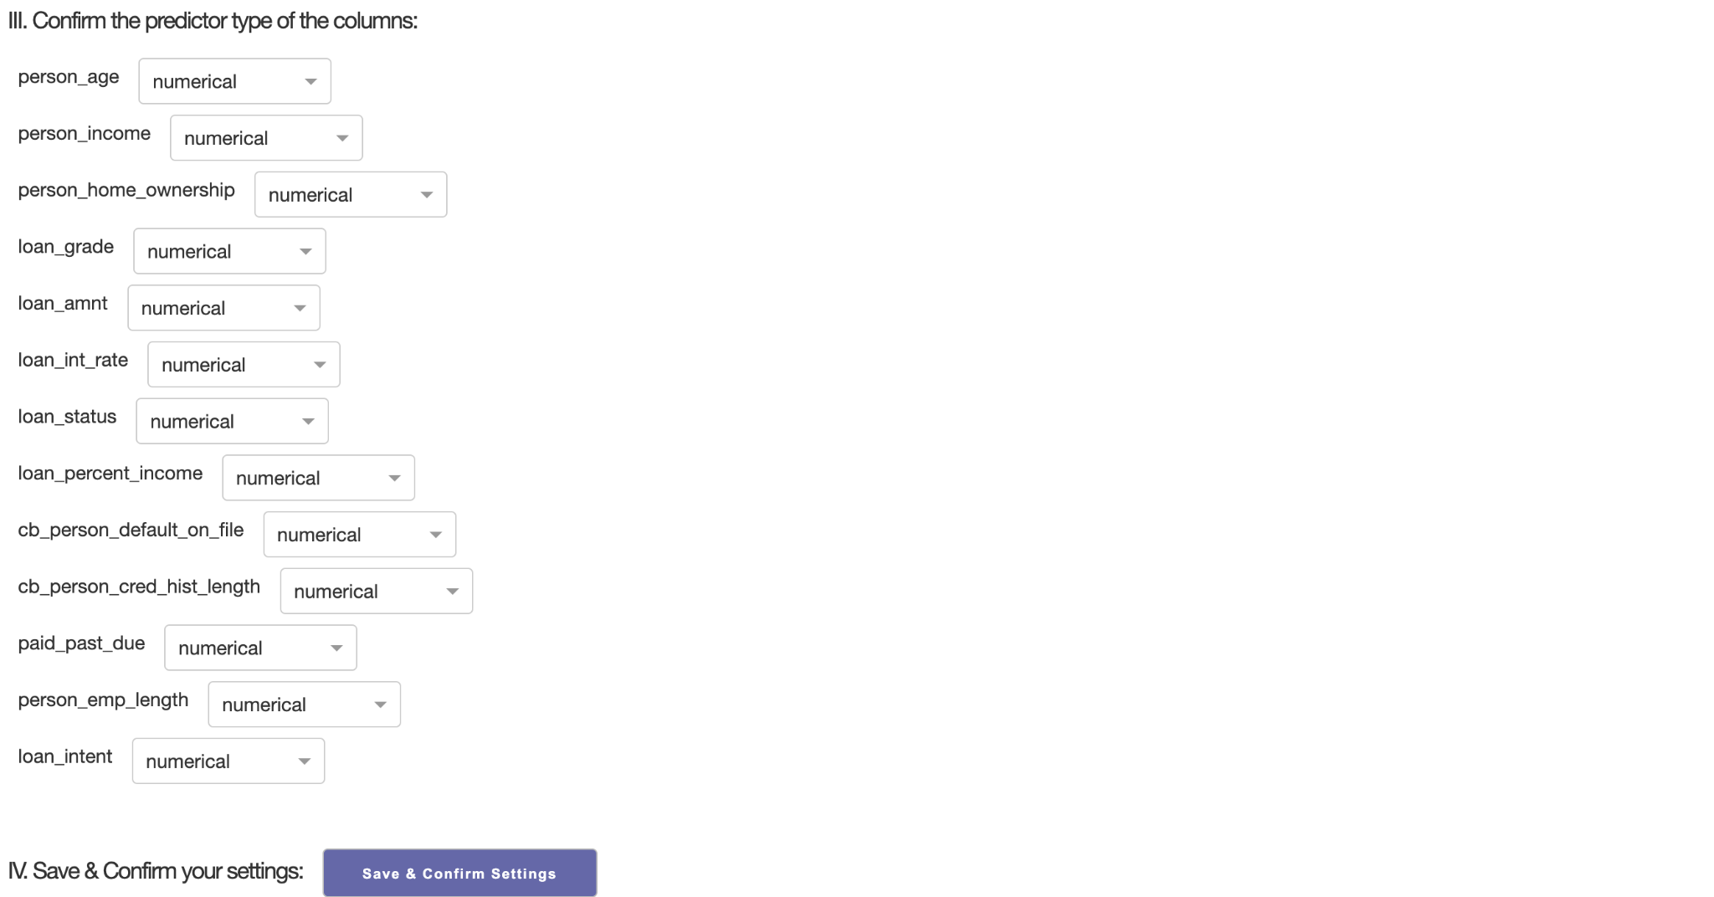

**4.2.2 Adjustments in “Good/ Bad Definition” Interface**

In Section 3.5.2.3.2, it is mentioned that the 2 common columns used for setting up this criteria are loan status and paid past due and thus, we have limited our users to choose between these two attributes as the Good/ Bad definition.

The section also highlighted that there would be 3 categories (i.e.: good, bad, indeterminate) if paid past due is chosen. Since it was assumed that the 3 intervals are continuous, only a slider from 1-120 was provided for indeterminate and thus the system could automatically infer the good and bad range given the indeterminate range set.

However, after consulting with our business partner, it is believed that more flexibility should be introduced to the interactive binning, as in allowing attributes other than loan status and paid past due to be the criteria of Good/Bad definition. For example, users can set the occupation of education and medical as a good definition and set age over 60 as a bad definition.

They also suggested that the good, bad or indeterminate range do not have to be continuous and they can have arbitrary cut points. For example, users can set the age intervals of 1-20, 40-42, 65-80 as a bad definition while setting the age intervals of 31-39 as a good definition and the age intervals of 21-30 as an indeterminate definition.

In light of the above suggestions, our new “Good/ Bad Definition” Interface has splitted into 3 parts for defining “Bad”, “Indeterminate” and “Good”. In each of the defining “Bad” and “Indeterminate” sections, users can choose to set any numerical interval criteria by filling in the intervals under the “Numerical Attributes”, or including any category criteria by choosing labels under the “Categorical Attributes”. Users are allowed to add or remove any of their choices and multiple definition criteria are applicable in the system. Any data entries that fall out of the “Bad” and “Indeterminate” definition criteria will be automatically considered as “Good”. Moreover, users can fill the weight of “Bad” and “Good” respectively in their favour.

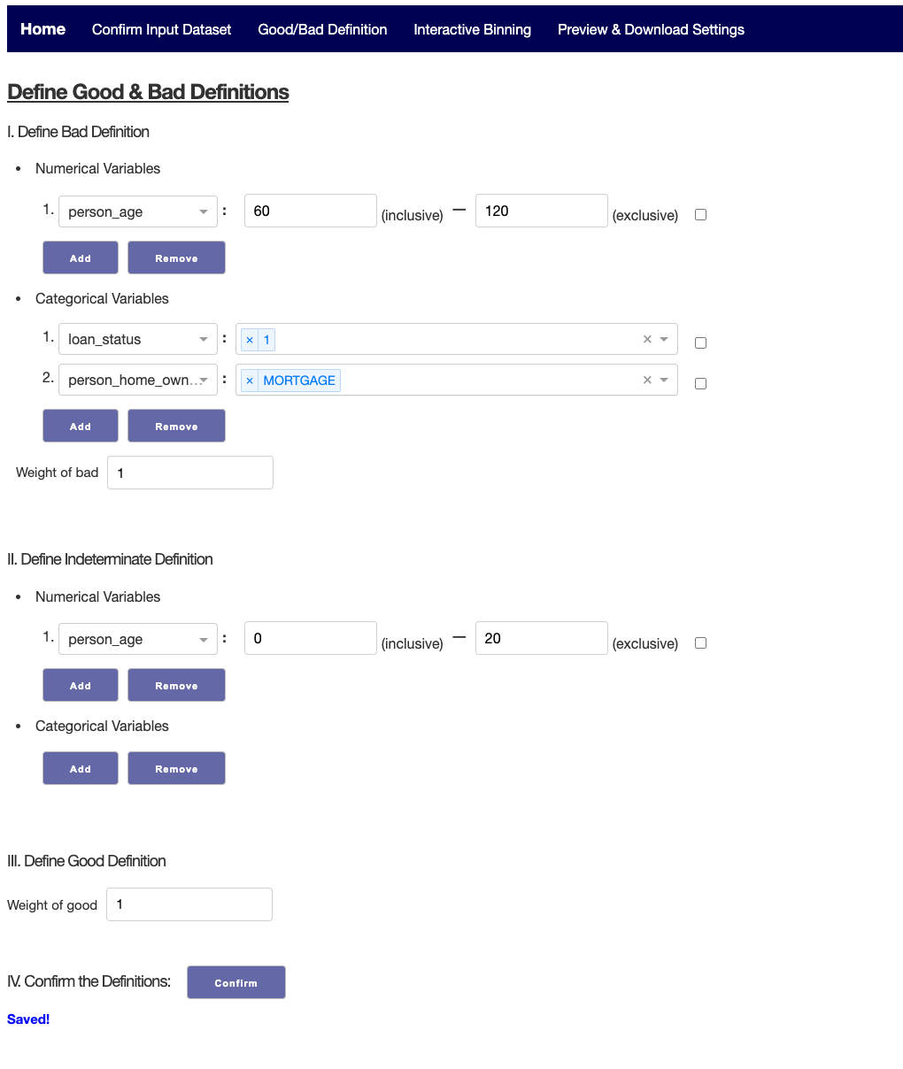

Figure 4.2 Updated UI Prototype of Interactive Binning Interface’s Good/Bad Definition Page (1st Part)

After saving the existing “Good/ Bad Definition” setting with the “Confirm the Definitions” button, information about the good, bad and indeterminate bin, as well as the frequency distribution of good and bad data will be displayed. This information is provided to help users to determine if their good/bad definition set is reasonable or not. Users may then proceed to the next stage “Interactive Binning” for further processing.

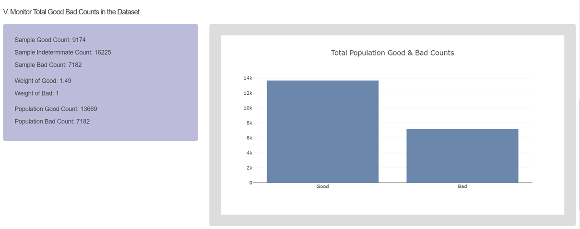

Figure 4.3 Updated UI Prototype of Interactive Binning Interface’s Good/Bad Definition Page (2nd Part)

**4.2.3 Adjustments in Interactive Binning Interface**

As mentioned in Section 3.5.2.3.3, the Interactive Binning interface includes 6 panels, ‘Select Predictor Variable Panel’, ‘Select Automated Binning Algorithm Panel’, ‘Interactive Chart Panel’, ‘Bin Parameters Control Panel’, ‘Summary Statistics (Before) Panel’, and ‘Summary Statistics (After) Panel’. Within the **‘**Bin Parameters Control Panel**’**, it is mentioned that ‘Bin Parameters Adjustments’ are built for users to perform manual treatments, like bin merging and splitting. No matter if it is numerical or categorical, the merge & split functions are also combined into a button and the system will automatically detect whether that is a split or merge command. However, this might cause confusion for users when inputting labels or ranges and it is also not user-friendly for users to come up with a command that do a split and merge at once, when they might expect performing the split or merge command separately.

Thus, for better functionality and clearer user’s interface, the buttons for each function are separated and a new **‘**Bin Parameters Control Panel**’** interface is developed.

Regarding categorical variables, there are 5 types of bin adjustments functions, including “Create Bin”, “Add Elements”, “Split Bins”, “Rename Bins” and “Merge Bins”.

When none of the bars are selected, “Create Bin'' function will automatically show up in the box. After entering the name of the bin created and specifying the elements to be included from the drop down list, users can click the “Create New Bin” button to preview changes. Similar to previous design, the preview changes part would show both the original and new binning setting, which both include the name or elements of each bin setting, ensuring that the adjustments made are what users expect. After confirming that the changes are right, users could submit the adjustments to update the mixed charts and statistical graph below but noted that submitting the adjustment does not save the binning setting. In case elements specified overlap with the other bins from the old bin setting, those elements will be automatically removed from its original bins.

When the user clicks the “Box Select” and selects only one of the bars, buttons designated for 3 functions will show up, which is “Add Elements”, “Split Bins”, “Rename Bins”. Clicking either one of the buttons, the selected bin information will also pop up, showing corresponding bin details like “Bin Name”, “Bin Element”,“Population Good Count” and “Population Bad Count”, which is “Bin Information” part in previous design. Right below the bin information part, it is the part where users can indicate the changes they wish to make. For “Add Elements”, users have to name the bin and specify the elements to be added from the drop down list. Similar to the “Create Bin'' function, elements overlapped will be automatically removed from their original bins. For “Split Bins”, users have to name the bin and specify the elements to be splitted from the drop down list, then the remaining elements will stay in its original bin with its original bin name. For “Rename Bins”, users only have to input a new name for the selected bin. After indicating the changes wish to be made, users can click the button for previewing changes and submit for further updates.

To better illustrate how the splitting function works, the following example is provided. In case the currently selected bin is [‘RENT’, ‘MORTGAGE’, ‘OWN’] under loan_intent and [‘RENT’, ‘MORTGAGE’] are chosen from from the drop down list, then the system will consider [‘RENT’, ‘MORTGAGE’] as an individual bin and split the original bin into [‘RENT’ & ‘MORTGAGE’], [‘OWN’].

When the user clicks the “Box Select” and selects more than one of the bars, only “Merge Bin'' function will show up in the box. All the selected bins’ info will be shown in the box and the user only has to input the new name for the merged bin. After that, users can click the button for previewing changes and submit for further updates.

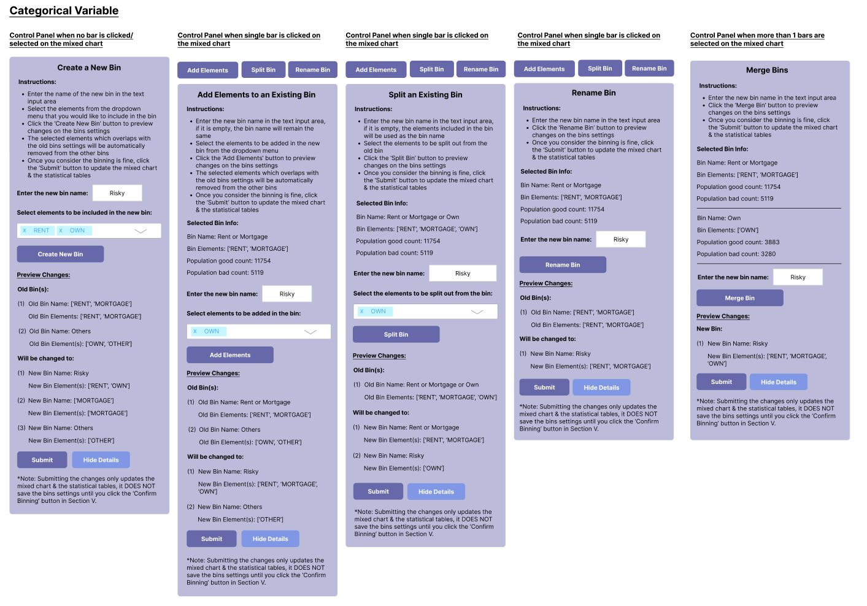

Figure 4.3 Updated Different Bin Adjustment Alternatives under various commands for Categorical Variable

Regarding numerical variables, there are 4 types of bin adjustments functions, including “Create Bin”, “Add Elements”, “Split Bins”, “Rename Bins” and “Merge Bins”.

When none of the bars are selected, “Create Bin'' function will automatically show up in the box. Similar to that for categorical variables, users have to input the name for the new bin. However, instead of choosing the variables, the range wished to be concluded should be inputted and multiple ranges can also be chosen by clicking the “Add” button. In case wrong ranges are chosen, they can still be removed by clicking the box beside them, followed by the “Remove” Button. The remaining procedures, from “Preview Changes”,“Submit” to overlapped range handling, are also the same as that for categorical variables.

When the user clicks the “Box Select” and selects only one of the bars, buttons designated for 2 functions will show up, which is “Adjust Cutpoint” and “Rename Bins”. For “Adjust Cutpoint”, similar to that for categorical variables, the bin information is also shown and users have to input the name for the new bin. The only difference is that users have to indicate the range that they wish to remain in the original bin and the range that is not indicated but overlapped in the old setting will then be splitted out as new bins. The remaining procedures, from “Preview Changes”, “Submit” to overlapped range handling, are also the same as that for categorical variables. For “Rename Bins”, the whole layout will be exactly the same as that for categorical variables.

To better illustrate how the adjusting cut point function works, the following example is provided. In case the currently selected bin is [[0,20), [80,100)] under age and the two old bin settings are [[0,20), [80,100)] & [[20,80), [100,110)], users input the two ranges [0,10) and [80,110). As a result, the system will consider [[0,10), [80,110)] as an individual bin and split the remaining ranges [10,20) & [20,80) into two new bins.

When the user clicks the “Box Select '' and selects more than one of the bars, , only “Merge Bin'' function will show up in the box. This function is exactly the same as that for categorical variables.

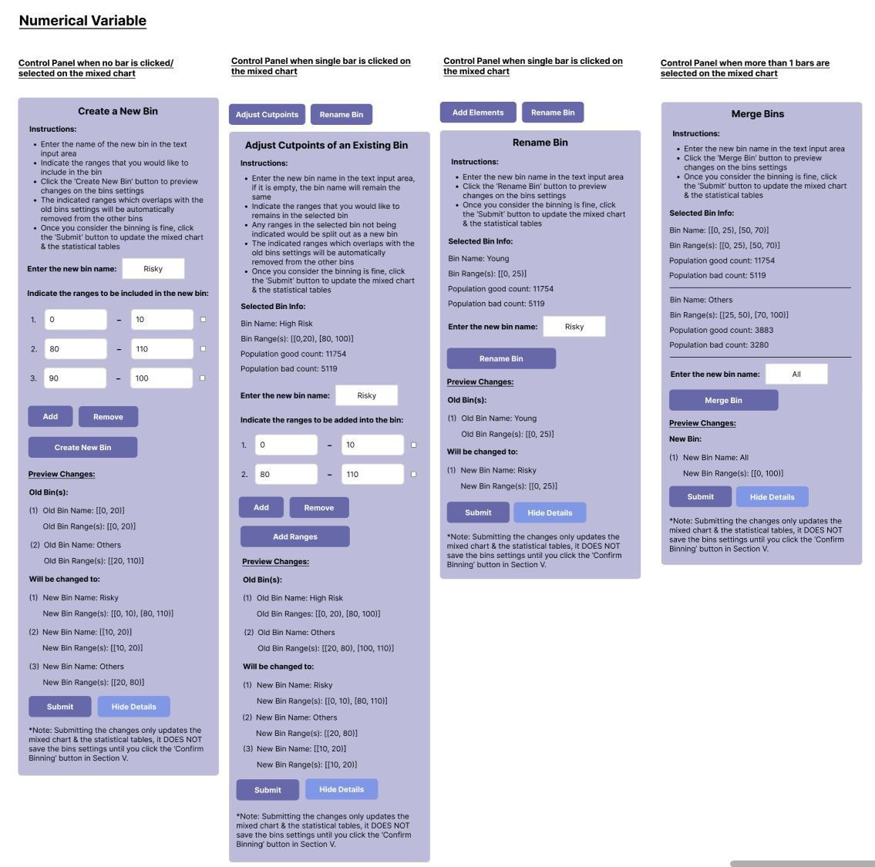

Figure 4.4 Updated Different Bin Adjustment Alternatives under various commands for Numerical Variable

**4.2.3 Final Credit Scoring Model Pipeline**

The overall design for the credit scoring model development pipeline is shown in Figure 4.5 below. As mentioned in Section 1.4, there are 5 main objectives of the project, including:

(1) Performing automated binning to provide initial data bins for later manual adjustment;

(2) Building an interactive binning interface that enables manual adjustments of bins along with required summary statistics and graphs;

(3) Constructing a visualization dashboard for monitoring binning performance based on criteria such as WOE and IV;

(4) Linking binning outcomes to a credit scoring model;

(5) Automating the reject inference process based on a defined objective function with constraints.

The Dataiku flow shown in Figure 4.5 consists of a total of 6 zones which are used to fulfill the 5 main objectives of this project:

(1) Input zone - containing the input credit risk dataset and the dataset created for the rejected applicants [1st Objective]

(2) Automated Binning Dashboard zone - involves computation of summary statistics & performs formatting based on the output from automated binning (i.e., initial dataset) [3rd Objective]

(3) Interactive Binning zone - manipulates the input credit risk dataset based on the bin settings obtained from manual binning using the interactive binning interface which will be discussed in Section 3.5.2 [1st & 2nd Objectives]

(4) Interactive Binning Dashboard zone - involves computation of summary statistics & performs formatting based on the output from interactive binning [3rd Objective]

(5) Reject Inference zone - involves reject inference implementation on the rejected applicants, Good/Bad Dashboard and Accept/Reject Dashboard [5th Objective]

(6) Credit Scoring Model zone - comprises of a machine learning model training recipe for building the credit scoring model, and the output credit scoring model, which could be used for deployment [4th Objective]



Figure 4.5 Proposed Credit Scoring Model Development Pipeline

**4.2.3.1 Input Zone**

This zone is provided to input the credit risk dataset.

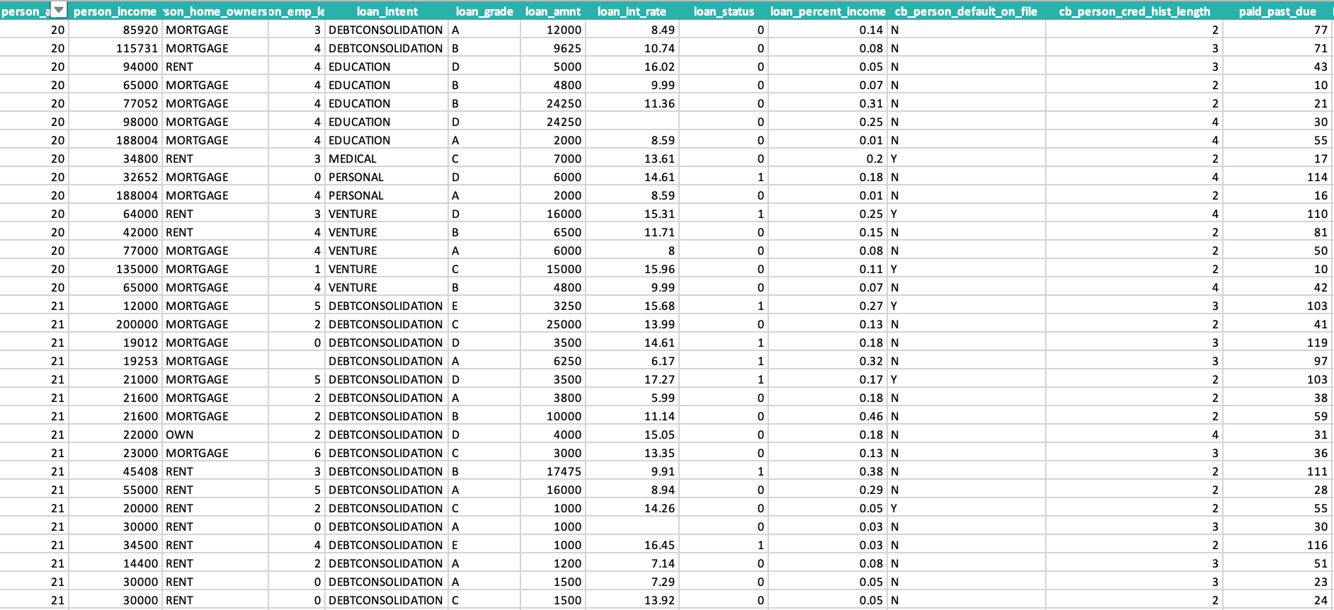

Figure 4.6 Input Dataset

**4.2.3.1 Automated Binning Dashboard Zone**

The Automated Binning Dashboard zone involves the computation of summary statistics & performs formatting based on the output from automated binning on the initial dataset.

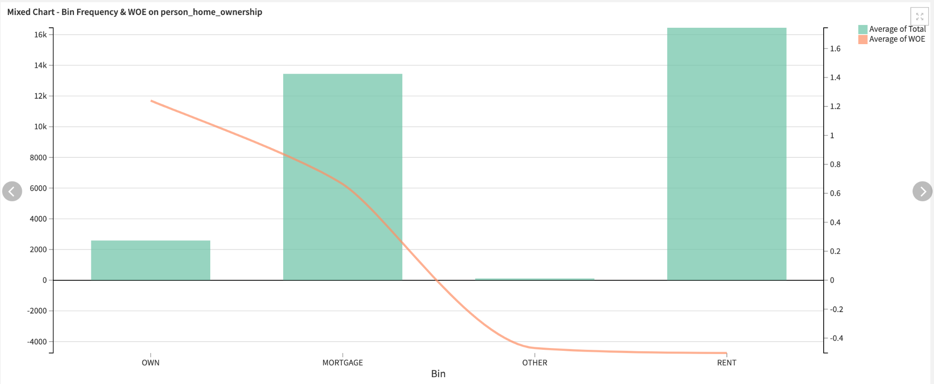

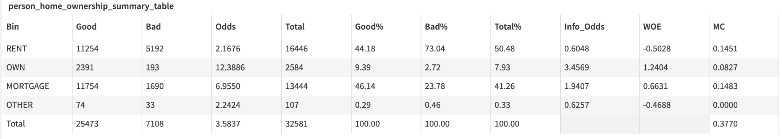

Figure 4.7 Automated Binning Dashboard

**4.2.3.2 Interactive Binning Interface**

The interactive binning consists of 4 major functionalities: Confirm input dataset, define good and bad definitions, interactive binning and Preview & Download settings.

The home page displays the input dataset to let the users check the number of rows and columns, as well as the dataset information,

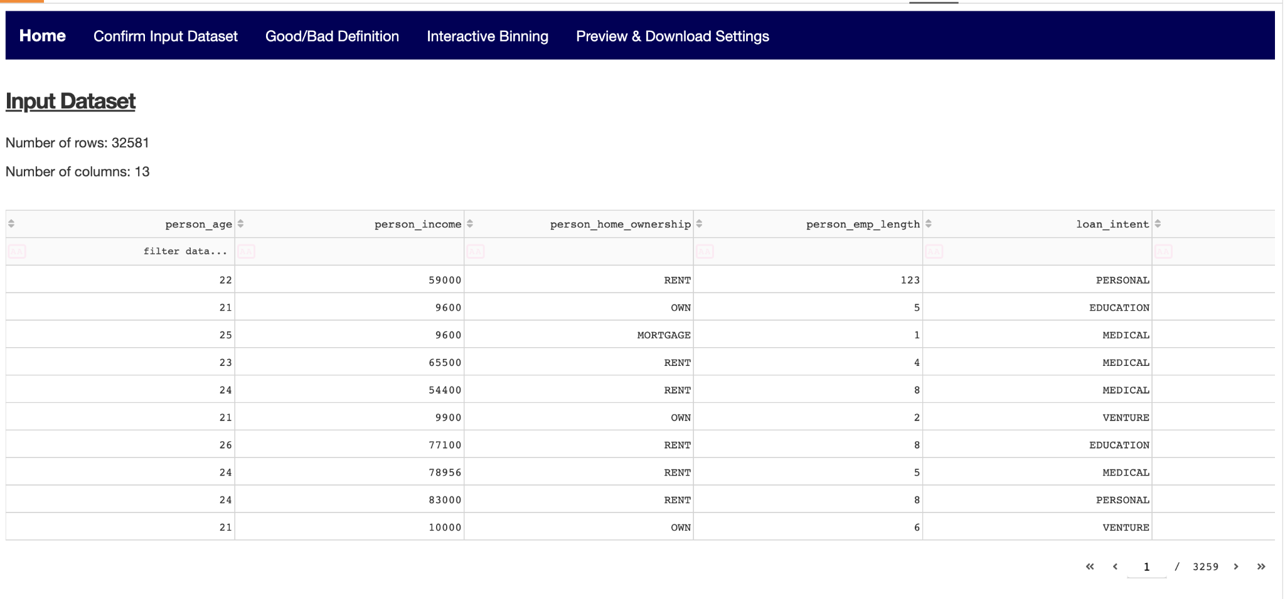

Figure 4.8 Home page of Interactive Binning Interface

As mentioned in Section 3.5.2.3.1, the first functionality is “Confirm Input Dataset” in which the users select which variables to be selected for binning. They are also required to check the type of variables (i.e. whether the variable is categorical or numerical).

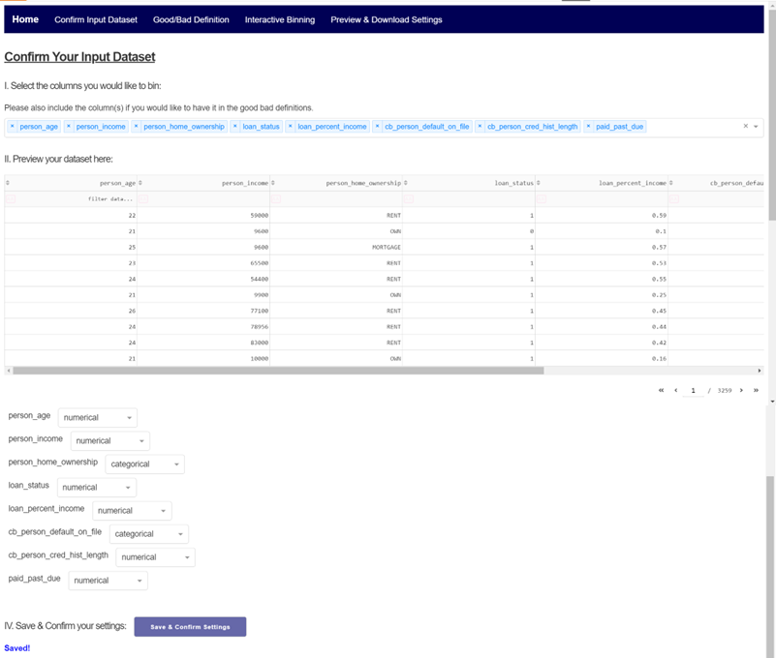

Figure 4.8 “Confirm Input Dataset” page of Interactive Binning Interface

As mentioned in Section 3.5.2.3.2, the second functionality is “Good/Bad Definition” in which the users can declare the criteria (including both categorical and numerical variable) for determining whether an observation is good, bad, or indeterminate.

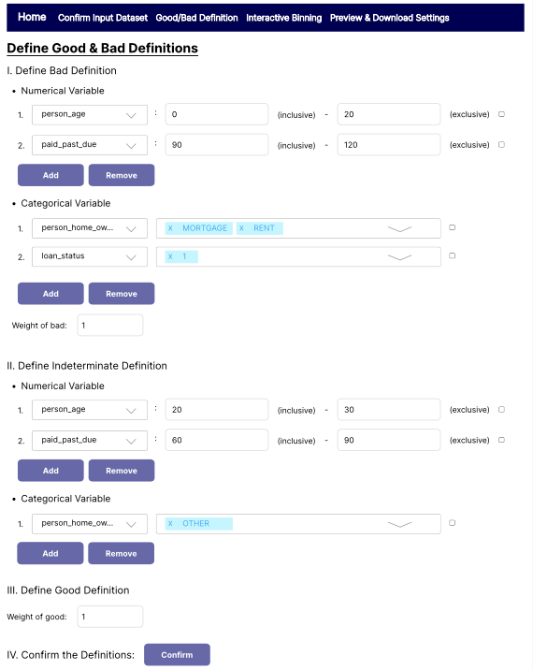

Figure 4.8 “Define Good & Bad Definitions” page of Interactive Binning Interface

As mentioned in Section 3.5.2.3.4, the third functionality is “Perform Interactive Binning” which is a page specifically designed for performing interactive binning task. It includes 6 panels, ‘Select Predictor Variable Panel’, ‘Select Automated Binning Algorithm Panel’, ‘Interactive Chart Panel’, ‘Bin Parameters Control Panel’, ‘Summary Statistics (Before) Panel’, and ‘Summary Statistics (After) Panel’

Within the ‘Select Predictor Variable Panel’, the user can choose from a drop-down list for which predictor variable to be binned. Within the ‘Select Automated Binning Algorithm Panel’, the user can choose from another drop-down list for the automated binning algorithm to be used for the initial binning. The ‘Interactive Chart Panel’, it mainly consists of a mixed chart. The mixed chart incorporates a bar chart, showing the Good, Bad, and Total count of each bin for the selected predictor variable to be binned, and a line chart, indicating the trend of the WOE value for each bin. Within the ‘Summary Statistics (Before) Panel’, and ‘Summary Statistics (After) Panel’, users can compare the summary statistics table, in which its detail explanation should refer to Section 3.5.3.1, of the existing bin setting (i.e.: After) and the bin setting since last changes.

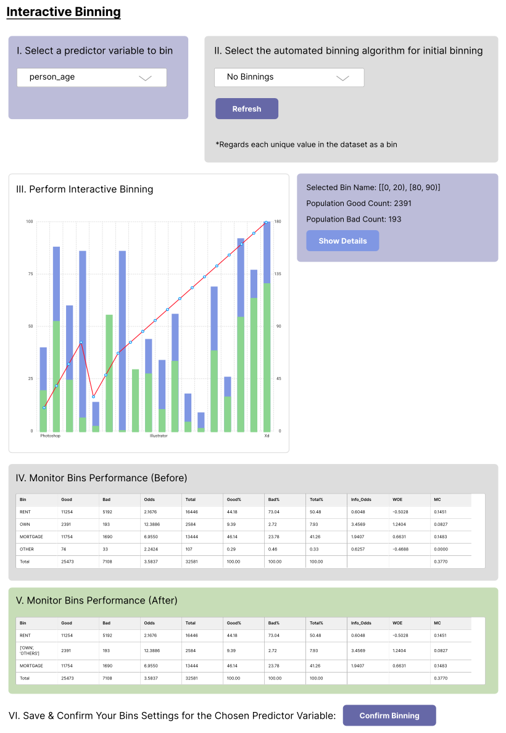

Figure 4.8 “Interactive Binningt” page of Interactive Binning Interface

Within the ‘Bin Parameters Control Panel’, it incorporates the functions like bin merging, splitting, and renaming, allowing users to perform manual treatments like adding specific cutpoint and rename bin. However, treatments for numerical and categorical variables are different.

Regarding categorical variables, there are 5 types of bin adjustments functions, including “Create Bin”, “Add Elements”, “Split Bins”, “Rename Bins” and “Merge Bins”. “Create Bin” is a function to select which variable to bin. “Add Elements” is a function to name the bin and specify the elements to be added from the drop down list. “Split Bins” is a function to specify the elements to be splitted from the drop-down list. “Rename Bins” is a function to input the new name for the selected bins. “Merge Bins” shows the selected bins’ info and input the new name for the merged bin.

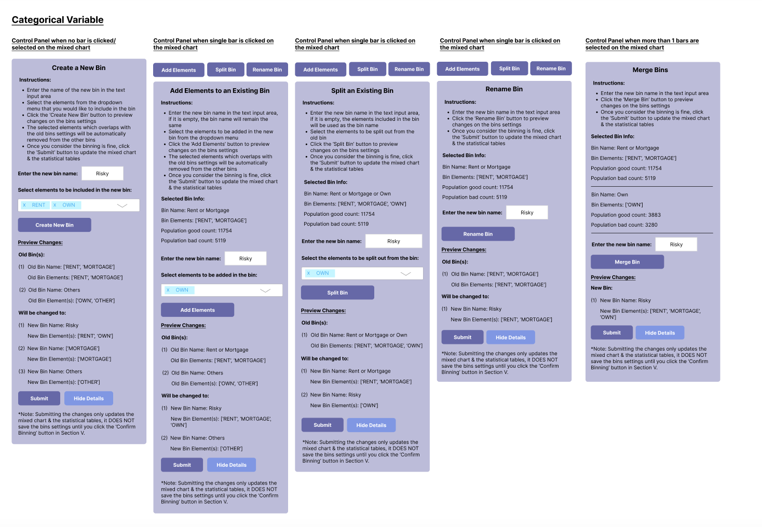

Figure 4.8 Different Bin Adjustment Alternatives under various commands for Categorical Variable

Regarding numerical variables, there are 4 types of bin adjustment functions, including “Create Bin”, “Adjust Cutpoints”, “Rename Bins” and “Merge Bins”. “Create Bin” is a function to input multiple ranges. “Add Elements” is a function to name the bin and specify the elements to be added from the drop-down list. “Adjust Cutpoints” is a function to indicate the range that they wish to remain in the original bin. The range that is not indicated but overlapped in the old setting will then be splitted out. “Rename Bins” is a function to input the new name for the selected bins. “Merge Bins” shows the selected bins’ info and input the new name for the merged bin.

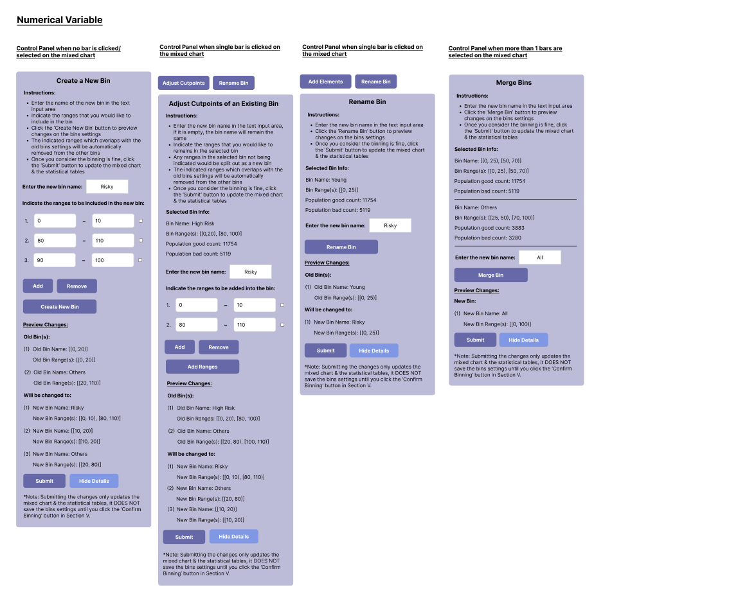

Figure 4.8 Different Bin Adjustment Alternatives under various commands for Numerical Variable

After manual binning has been performed, users can preview the binned dataset, summary statistics tables, and mixed charts showing the frequency distributions of bins and WOE trends for each predictor variable. Once the user is satisfied with the binning, the bins settings could be downloaded through pressing the save bins settings button.

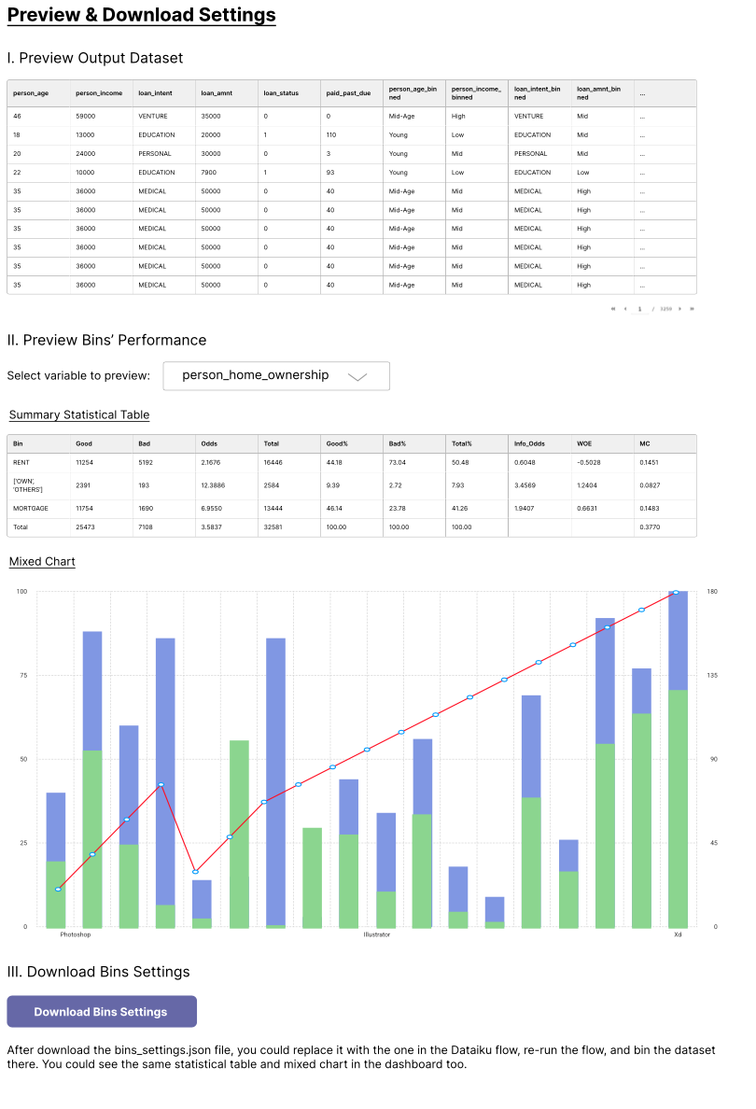

Figure 4.8 “Preview and Download Settings” page of Interactive Binning Interface

**4.2.3.4 Interactive Binning Dashboard Zone**

Similar to Automated Binning, the interactive binning dashboard consists of the Mixed Chart and Summary Statistics Table based on users’ requirements for binning.

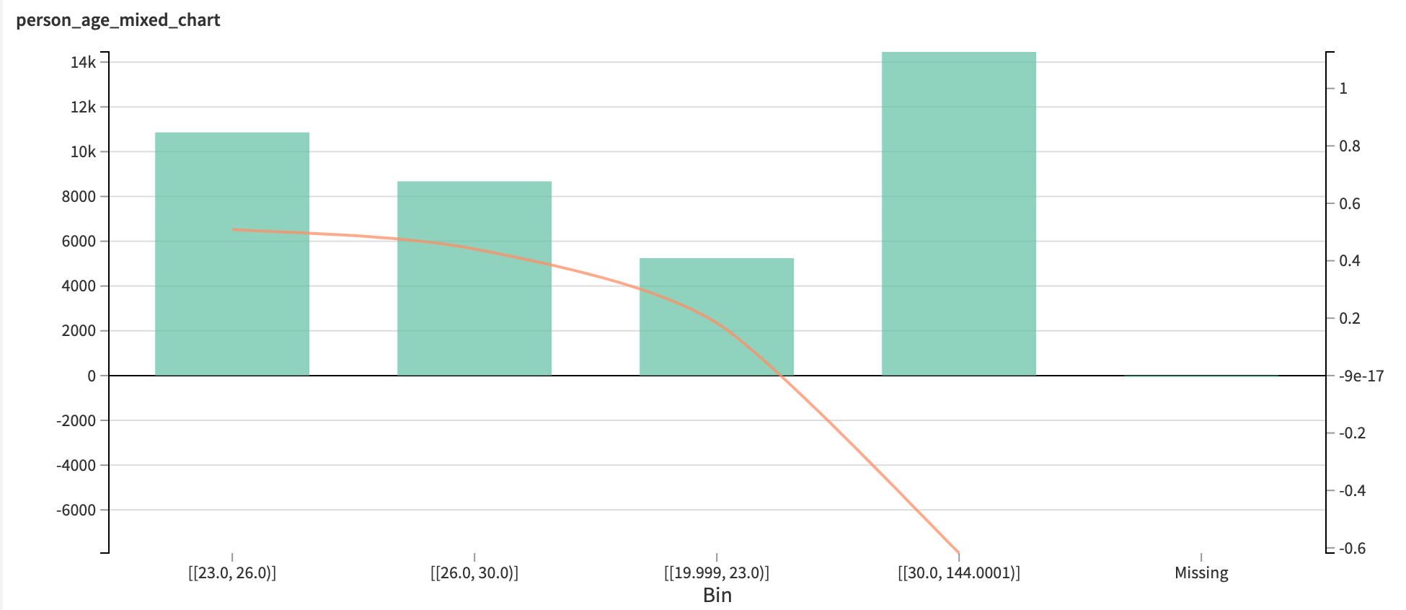

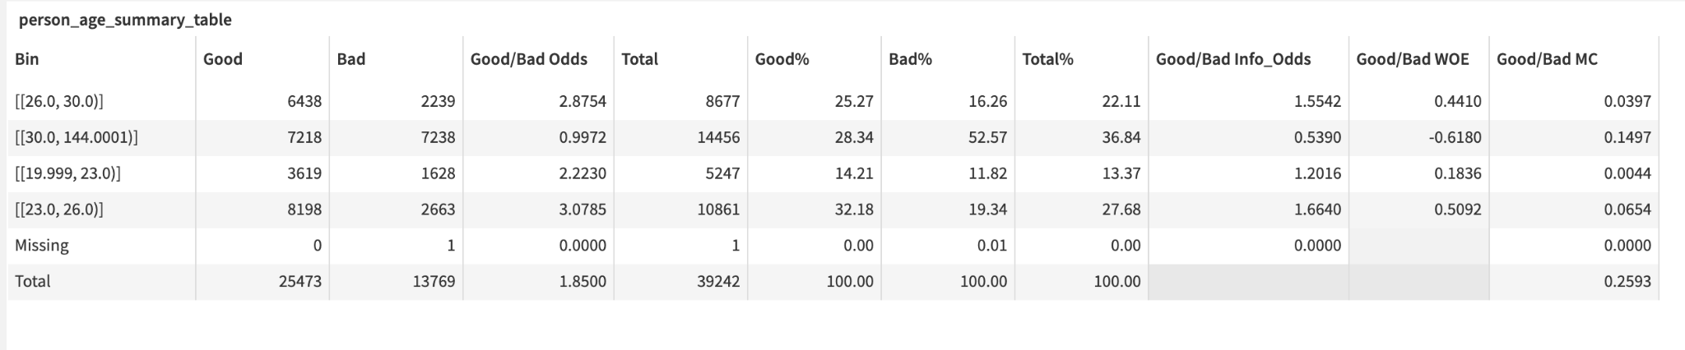

Figure 4.8 Interactive Binning Dashboard

**4.2.3.5 Reject Inference Zone**

To reduce bias in the dataset, the rejected applicants will be included in the credit scoring model. All the rejected applicants are assigned to Bad due to the fact that As the rejected population is usually those who are riskier lending money, applicants with similar characteristics could also be assumed to result in a lower credit score. Then, data preprocessing is performed on both rejected and accept datasets and combined the two datasets together. After that, the combined dataset is binned with the same bin setting from the accepted dataset. Finally, the summary statistic tables is computed and the mixed chart is generated (similar as automated binning dashboard and interactive binning dashboard).

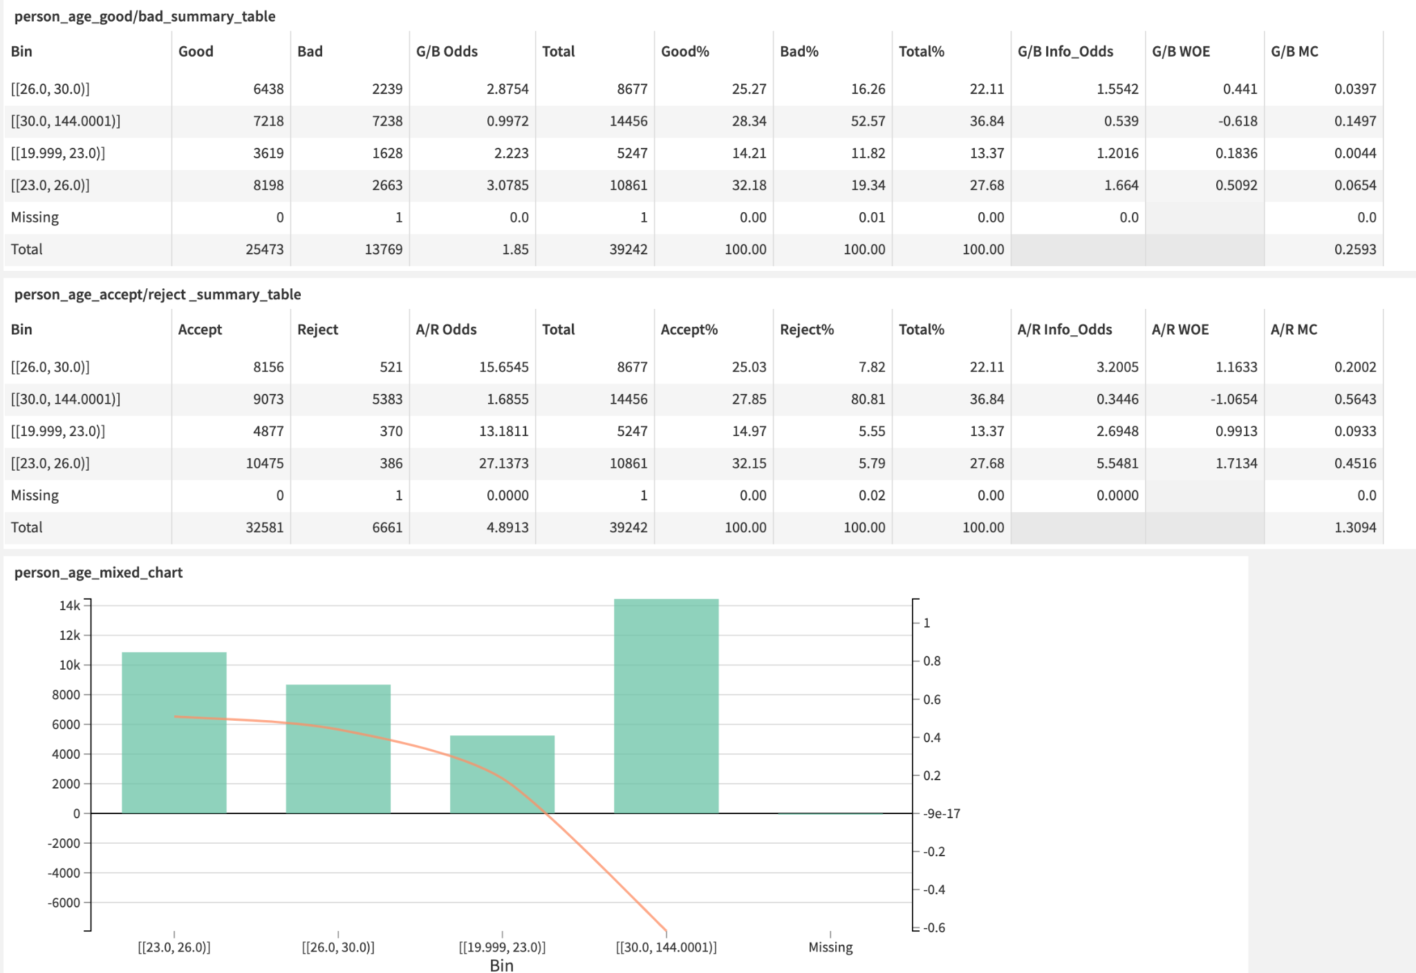

Figure 4.9 Reject Inference Dashboard

**4.2.3.6 Credit Scoring Model Zone**

**Lastly, two** credit scoring models are generated. One is for accepted applicants and another one is for both accepted and rejected applicants. Users can choose different credit scoring models and the ROC curves are shown under each model to provide references for the users to choose which credit scoring models to be selected.

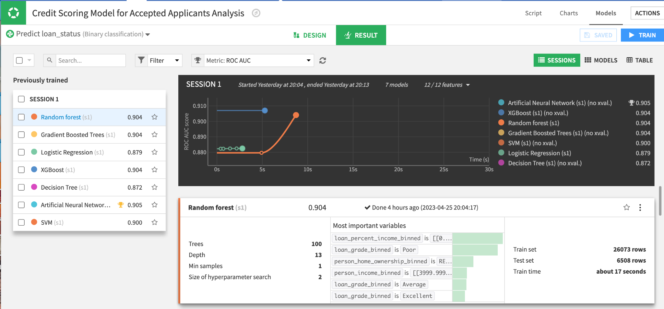

Figure 4.9 Credit Scoring Model

**5. Project Evaluation and Discussion**

**5.1 Introduction**

Every little error adds up to the accuracy and reliability of the final model. Therefore, testing is very important to make sure the model is correct and error-free. Testing, which divides into validation and verification, tries to find the differences between the expected and observed system behavior. Validation makes sure that the right product is built and the system meets the requirement. Verification makes sure that the product is built right. The quality of the implementation is checked by ensuring the function works correctly with no defects. Hence, both the validation and verification are tested to evaluate the result of the project.

The first criterion to test the **verification** of the project is related to correctness. Backend computation will be encapsulated into several classes, which are separated from the web app, and perform testing these classes to ensure the correctness of backend computation. Our method is to use pytest for running unit test cases and generating unit test reports and pytest-cov for generating coverage report modules. Session 5.2 will discuss using unit testing to verify the model’s correctness.

The second criterion to test the **validation** of the project is related to usability. Usability is used to access whether the model meets the requirements and solves the business problem. As mentioned in the abstract, the problem of the traditional credit scoring model involves high time cost, human resources cost, and high expertise requirements. The user acceptance test helps to evaluate the performance and the effectiveness of the dashboard. Session 5.3 will talk about how to use the User Acceptance Test to validate the model’s usability.

**5.2 Correctness - Unit testing**

In this unit testing, the correctness of the codes of the calculation of the statistical information provided by the summary statistics table is tested by systematically finding defects in a short period (SmartBear, N.A.). However, not all the cases are included because we would like to have the highest likelihood of finding defects with the minimum amount of time and effort. Therefore, our approach is to use both the manual calculation by Excel and Pytest which is one of the unit testing frameworks mentioned above to validate our code.

**5.2.1 Test Plan**

**5.2.1.1 Introduction**

Unit testing is to design tests that have the highest likelihood of finding defects with the minimum amount of time and effort. The unit testing aims to debug the possible errors in the coding computation in our pipeline, specifically for automated and interactive binning. We encapsulated the backend computation into several classes (separate from the web app). We performed testing on these classes to ensure the correctness of backend computation by using pytest and pytest-cov modules as mentioned in Session 5.1.

To evaluate in an effective and efficient way, each test case is chosen precisely. The step of the test case is as follows.

1. Choose input data/software configuration
2. Define the expected outcome
3. Run the program/ method against the input and record the result
4. Compare the results against the expected outcome

**5.2.1.2 Classes to be tested**

This section describes the flow of ‘Good Bad Definition’ page in the web app and how each class helps with it:

(a) Users can define a dynamic number of ranges and elements for numerical and categorical attributes respectively.

(b) Before translating the good and bad definitions into a desired format for storing in memory, we need to validate user input, to avoid unexpected outcomes in the interface and show error to the user, here we need to validate: Whether upper bound is greater than the lower bound for numerical ranges. In this case, **GoodBadDefValidator** class is needed to check the boundary cases.

(c) Since these ranges/elements may overlap with one another (within solely ‘bad’ or solely ‘indeterminate’), to improve memory efficiency (i.e., reduce the size of memory storage needed to store the good bad definitions), we need to merge overlapping ranges/elements. Therefore, the **GoodBadDefDecoder** class is needed to merge the overlapping ranges and elements.

(d) After that, we have to validate whether the ranges/elements between ‘bad’ and ‘indeterminate’ definitions overlapped (if overlapped, then the error should be shown). Therefore, the **GoodBadDefValidator** class is needed again.

(e) Finally, after successfully storing the good and bad definitions, we have to calculate the sample and population good, indeterminate, and bad count and show that to the user (as well as the bar chart). Therefore, **GoodBadCounter** class is needed to calculate the samples sizes.

After understanding the flow of ‘Good Bad Definition’ in the web app, there are a total of 4 classes and methods listed for the unit testing.

**(1) GoodBadDefDecoder**

The is the class for merging overlapping good bad definition ranges/elements for the same type (bad or indeterminate) as mentioned in step (c) above. For the numerical variable, we will merge the range together. For example, we will merge [50, 60] and [55, 70] into [50, 70] for the age group. For the classical variable, the input of [‘OWN’, ‘RENT’] and [‘MORTGAGE’, ‘RENT’] will be merged into [‘OWN’, ‘RENT’, ‘MORTGAGE’] as the output.

**(2) GoodBadDefValidator**

This is the class for validating user inputs for good and bad definitions. Between numerical ranges of bad and indeterminate, which is related to step (d). If the range of [50, 60] is set to be bad while the range of [40, 51] is set to be indeterminate, this case is considered to be invalid and returns FALSE. This type of validation is also applicable to the categorical elements of the bad and indeterminate definitions. For example, if the user set [‘OWN’] as bad and [‘OWN’, ‘RENT’] as indeterminate, this classification is also considered to be invalid and returns FALSE. Moreover, this class also tests if all numerical ranges entered by the user have an upper bound greater than the lower bound, which is related to step (b). For example, if the user sets the upper bound as 30 and the lower bound as 50, it is considered to be invalid and returns FALSE.

**(3) GoodBadCounter**

This is the class for counting the number of good and bad samples/populations in the column, which is related to step (e). For example, the get_statistics() method returns the sample bad count, sample indeterminate count, sample good count, good weight, bad weight, population good count, and population bad count. Other helper methods e.g., count_sample_bad(), and count_sample_indeterminate() are also tested individually.

**(4) StatCalculator**

This is the class for calculating the statistical values for the summary statistics table to display the mixed chart and the statistical tables. The summary statistics table includes the statistical information of the good, bad, good_odds, and bad_odds, which are shown in Table 3.3.

**5.2.1.3 Prepare test case**

As mentioned in Session 5.2.1.1, the first thing to do in unit testing is to choose the input data and define expected outcomes. White box testing, specifically Basic path testing, which means seeing the code while developing the test cases is first used. With that, every branch and hence every statement in the code should be executed during the test at least once, and a coverage of 100% would be observed as evidence. Secondly, black box testing which means the code is not referred to when developing test cases includes

(1) Boundary cases e.g., empty dataset, boundary values e.g., 0 and 1;

(2) Typical cases e.g., use a normal dataset i.e., Kaggle one, with normal settings, i.e., paid_past_due [90, 120] for bad, [60, 90) for indeterminate;

(3) Other cases e.g. in testing GoodBadDefValidator– test_validate_numerical_bounds, we include character & strings as input instead of numbers.

As mentioned in Session 5.2.1.2, there are 4 classes to implement. The test cases are prepared based on these 4 classes:

**(1) Test_GoodBadDefDecoder**

This is the test to validate the **GoodBadDefDecoder** class. There are a total of 2 test scenarios for testing. The details of the test case design under each scenario are shown in Figure 5.1.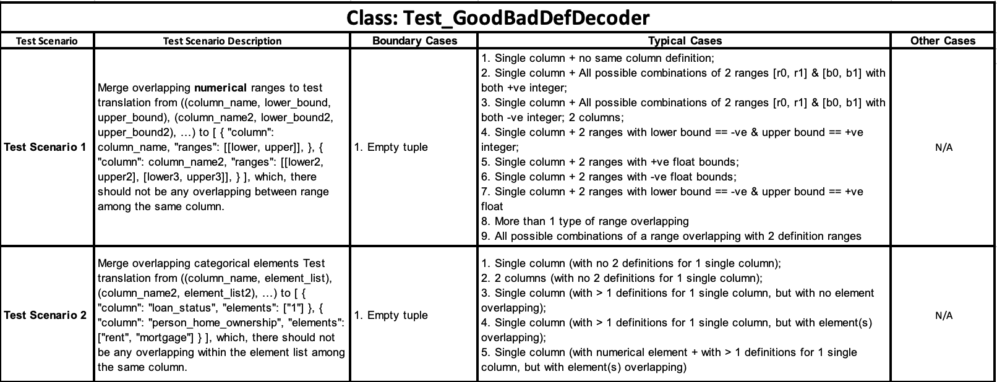

Table 5.1 Test Scenario and test case details of GoodBadDefDecoder class

**(2) Test_GoodBadDefValidator**

This is the test to validate the GoodBadDefValidator. There are a total of 3 test scenarios for testing. The details of the test case design under each scenario are shown in Appendix 1.

**Test Scenario 1**: Check if any overlapping definitions between bad & indeterminate numerical definition ranges. Test check any overlapping between bad & indeterminate definition ranges, which both are in the form of: [ { "column": column_name, "ranges": [[lower, upper]], }, { "column": column_name2, "ranges": [[lower2, upper2], [lower3, upper3]], } ], if have overlapping, the expected result is a Boolean False, else, if no overlapping, expected result is a Boolean True.

**Test Scenario 2**: Check if any overlapping definitions between bad & indeterminate categorical definition elements.

**Test Scenario 3**: Check if given a list of definitions, whether all boundaries are in numerical values, and if all upper bound > lower bound. Test check any non-numerical boundary values entered by the user and if all upper bound > lower bound, which the list of definitions are in the form of: ( ("paid_past_due", 70, 80), ("paid_past_due", 39, -1), ("person_age", 30, 100), ... ) if non-numerical value(s) existed or some upper bound <= lower bound, expected result is a Boolean False, else, the expected result is a Boolean True.

**(3) Test_GoodBadCounter**

This is the test to validate the GoodBadCounter. There are a total of 6 test scenarios for testing. The details of the test case design under scenarios 1-5 are shown in Appendix 2 and the test case design under scenario 6 is shown in Appendix 3.

**Test Scenario 1**: Test the given data frame and a dictionary telling the bad definitions, and count the number of bad samples.

**Test Scenario 2**: Test the given dataframe and a dictionary telling the indeterminate definitions and count the number of indeterminate samples.

**Test Scenario 3**: Test the given dataframe, the count of sample bad, and the count of sample indeterminate, returns the number of good samples.

**Test Scenario 4**: Test the given count of sample good, and weight for good, and returns the population, good count.

**Test Scenario 5**: Test the given count of sample bad, and weight for bad, returns the population bad count.

**Test Scenario 6**: Test the given dataframe, the count of sample bad, and the count of sample indeterminate, returns the number of good samples.

There is a total of 36 test cases that are being used to validate the codes. Each test case would be assigned one good/bad definition and one binning algorithm. For definitions, we would use definitions 1 or 2 to determine whether the customer is good/bad. For the first definition, the good/bad definition is simply determined by loan status. Good means the loan_status column shows '1' while bad means the loan_status column shows '0'. For definition 2, it is related to the paid past due and the loan status, which is shown in Section 3.5.2.3.2.

For binning methods, there are 3 types of binning algorithm to be tested, which includes no binning, equal width, and equal frequency. For the no-binning part, it would simply calculate the statistical information by the unique values for each variable. For the equal width, we would divide a range of values into fixed-width intervals. or set the total number of bins. For equal frequency, we would separate the binning by 1000 as a group. The differences in the usage of definitions of good/bad and algorithms can show the variety of possible errors of our coding on the calculation of the summary statistics by using different binning methods including equal width and equal frequency. Moreover, it can also show the derivation between the performance of different definitions and algorithms. We pick the columns of person_age, person_income, person_home_ownership, and loan_intent as it represents the variety of the data type, in which the column can be categorical or numerical. With age having a lower range and income having a bigger range, we would like to reflect differences in the range of the numerical variable. Moreover, columns of paid_past_due and loan_status are also selected to make sure the target variable is also on the right track.

**(4) Test_StatCalculator**

This is the test to validate the GoodBadCounter. There are a total of 5 test scenarios for testing. The details of the test case design under each scenario are shown in Appendix 4.

**Test Scenario 1:** Compute percentage based on given nominator and denominator to test the computation of percentage

**Test Scenario 2**: Compute odds based on given good and bad counts to test the computation of good and bad counts

**Test Scenario 3**: Compute info_odds based on given good% and bad% to test the computation of good% and bad%

**Test Scenario 4:** Compute woe based on given info_odds to test the computation of WOE.

**Test Scenario 5:** Compute mc based on given good%, bad%, and woe to test computation of mc

After all, the expected outcome is calculated by the Excel sheet manually and compared with the results generated by the web apps. If both results are the same, it means there is no calculation error.

**5.2.2 Test Result**

Two reports are being used to evaluate the expected result of the unit testing.

**5.2.2.1 Unit testing reports**

A unit testing report is a document that contains the results of unit tests that have been run on a software application or system. The report summarizes the test cases that have been run, the test results, and any issues or defects that have been identified during testing.

It includes the following elements to evaluate the result:

1. The expected output of the test
2. The actual output of the test
3. Whether the test passed or failed
4. The date and time of the test execution
5. Any issues or defects that were detected during testing

The detailed record of the tests that have been run, the results of those tests, and any issues that have been identified, can be used to identify performance bottlenecks, reliability issues, or other problems that may impact the overall quality of the software.

**5.2.2.2 Coverage report**

A coverage report refers to a report generated by an automated testing tool that measures the extent to which a particular codebase has been exercised by the test suite. Coverage reports can provide developers with insights into how well their tests are covering the code and can help identify areas of the code that may have been overlooked or are under-tested. Different types of coverage reports can measure different aspects of code coverage, such as statement coverage, branch coverage, or path coverage. Ultimately, the goal of coverage reports is to help developers write more effective tests and improve the overall quality of their code.

In our case, we cover different variables, including both numerical and categorical variable to make sure the test case cover as much variety of the test case as it can. In the coverage report, the test cases cover 82.7% of the code, which shows that the codes are reliable and representative.

**5.2.2.3 Overall**

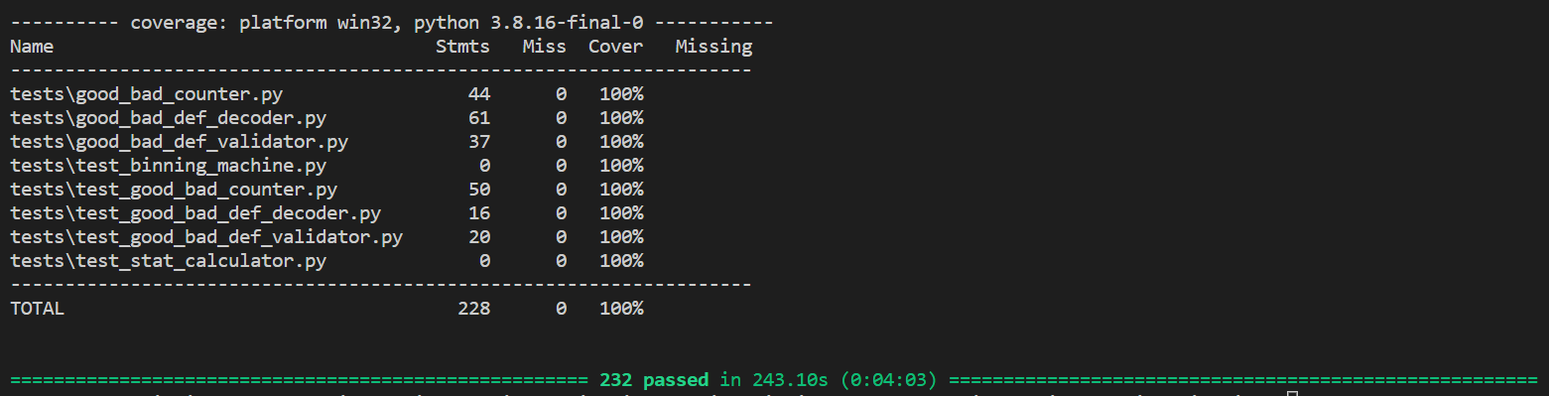

Figure 5.2 Result Generated from the Coverage Report

Coverage for all class files is 100% (i.e., all statements have been run during the tests), along with 100% unit test pass rate (i.e., all tests have computed result = expected result), we could conclude that for ‘Good Bad Definition Page’ part, all computation results are reliable and correct.

Both the unit testing report and the coverage report show that our interface is reliable and correct. Although test cases were developed using white box testing and black box testing, which ensured that all statements in the code has been executed at least once, and the boundary cases, as well as special cases, are being tested and achieved high coverage and test passing rate. However, it does not mean that our solution must have no defects. but we could still conclude that it is highly reliable in its correctness in normal use cases.

**5.3 Usability - User Acceptance Test**

After the dashboard is completely developed and has been approved in QA tests, the final stage, before releasing a dashboard, will be to request a key end-user to perform User Acceptance Test (UAT). The User Acceptance Test will include some questions regarding whether the model and dashboard developed can meet the requirement of the business partner and solve the problem of high time cost, high human resources cost, and high expertise requirements. In this project, UAT is performed by Sprint Milestones requesting the dashboard.

The result of UAT can evaluate the effectiveness and user-friendliness of a dashboard interface (Silvia, 2022). It can answer specific questions and test hypotheses about the dashboard's usability. The test involves asking participants to perform a task while thinking out loud (Lysy, N.A.), and the results of the study can identify areas of improvement for the dashboard.

**5.3.1 Criteria of UAT**

The UAT is essentially a signoff of the dashboard, telling the designer that the dashboard is up to expectations both in contents, functionality, dashboard design and time efficiency, which will be used as 4 main elements of the UAT in this project (Shreya, 2022).

First of all, “content” checks whether the project outcomes are as requested and accurately fulfilling the business requirements defined at the beginning of the project:

Meanwhile, “functionality” check whether the performance of the project outcomes is ideal for achieving the goal of building credit scoring models, and if there are any errors/ambiguous behaviour in the Dataiku project interfaces.

Thirdly, “dashboard structure” check whether the layout design of the project outcomes makes sense and the user interfaces are appealing and clear.

Lastly, “time efficiency” checks whether the project outcomes have fast response time during user interactions, and if it could improve the overall efficency for the whole credit scoring process.

The feedback received from the user to update and revise the dashboard to improve its usefulness and functionality. This feedback is crucial to the success of the dashboard deployment, as it considers the requirements of the end-users, and ensures that the dashboard meets the expectations of the business stakeholders.



Figure 5.3 The User Acceptance Survey

**5.3.2 Survey Result and Analysis**

The score of each area is XXXX.

The result shows that Sprint Milestone satisfies the dashboard’s content, functionality, and dashboard structure. The dashboard also fulfills the ultimate goal of this project: reduce the time cost, human resource cost, and expertise requirement.

**6. Conclusion and Future Work**

The major challenges of the current credit scoring industry are high time cost, human resources cost, and high expertise requirements for building and updating a credit scoring model as mentioned in Section 1.3. The automated credit scoring model development pipeline proposed in this paper could greatly simplify and improve the efficiency of the whole process through providing intuitive graphical interfaces among the development process using the Dataiku platform. The pipeline contains 5 major components, including automated binning, interactive binning, visualization dashboards, credit scoring model, and automated reject inference solution. In Chapter 2, the literature review is conducted to provide background information on the topic and comparisons between different tools and models. The methodologies introduced in Chapter 3 are designed based on the research results. Up to now, the first part of automated binning, which is to apply an equal width binning algorithm on the initial credit risk dataset with a width equal to 1, has been completed. In addition, part of the UI prototype of interactive binning is also drafted and presented in Section 3.5.2.3. The Automated Binning Visualization Dashboard has been completed as shown in Figure 4.2 and Figure 4.3 in Section 4.3. Finally, the research and implementation of the linkage of bins to the credit scoring model have also been investigated. In Chapter 4, the interactive binning design is updated and the reject inference is included in the final. In Chapter 5, the unit testing and user acceptance survey are used to evaluate the effectiveness of the overall project. The credit scoring development pipelines can achieve the ultimate goal of solving the problem of high time cost, high human resources cost, and high expertise requirements of the credit scoring process. However, there is still a limitation on the reject inference that we simply treat all the rejected cases as bad (proposal 1 as shown in Section 3.6. Therefore, we would continue to work on proposal 3 of the reject inference as mentioned in Section 3.6.

**7. Reference**

Anderson, Raymond A. Credit Intelligence and Modelling: Many Paths Through the Forest of Credit Rating and Scoring. Oxford University Press, 2022.

Breiman, L. (2001). Random Forest. Machine Learning, 45(1), 5–32.<https://doi.org/10.1023/a:1010933404324>

Brown, I., & Mues, C. (2012). An experimental comparison of classification algorithms for imbalanced credit scoring data sets. Expert Systems With Applications, 39(3), 3446–3453.<https://doi.org/10.1016/j.eswa.2011.09.033>

CapitalOne (2022). *What Is a Good Credit Score?.* <https://www.capitalone.com/learn-grow/money-management/what-is-a-good-credit-score/>

Celio Di Cellio Dias, P., Experian, S., Forti, M., Bradesco, & Witarsa, M. (2018). A comparison of Gradient Boosting with Logistic Regression in Practical Cases. SAS Global Forum Proceedings.<https://www.sas.com/content/dam/SAS/support/en/sas-global-forum-proceedings/2018/1857-2018.pdf>

Christopher M. Bishop. (1994). Neural networks for pattern recognition. Choice Reviews Online, 31(10), 31–5500.<https://doi.org/10.5860/choice.31-5500>

CREDIT SCORING APPROACHES GUIDELINES (2019). World Bank Group, Web site:<https://thedocs.worldbank.org/en/doc/935891585869698451-0130022020/original/CREDITSCORINGAPPROACHESGUIDELINESFINALWEB.pdf>

Crook, J., & Banasik, J. (2004). Does reject inference really improve the performance of application scoring models? Journal of Banking and Finance, 28(4), 857–874.<https://doi.org/10.1016/j.jbankfin.2003.10.010>

Dataiku (N.A.). Connecting to data.<https://doc.dataiku.com/dss/latest/connecting/index.html>

Dataiku (N.A.). Everyday AI, Extraordinary People.<https://doc.dataiku.com/dss/latest/connecting/index.html>

Deepanshu, B., (N.A.). WEIGHT OF EVIDENCE (WOE) AND INFORMATION VALUE (IV) EXPLAINED.<https://www.listendata.com/2015/03/weight-of-evidence-woe-and-information.html>

Desjardins, S. L. (2018). Evaluation of Different Approaches to Reject Inference: a case study in Credit Risk. SAS Global Forum Proceedings.<https://www.sas.com/content/dam/SAS/support/en/sas-global-forum-proceedings/2018/2731-2018.pdf>

​​Domo (N.A.). *The benefits of using dashboard visualization tools*. <https://www.domo.com/learn/article/the-benefits-of-using-dashboard-visualization-tools>

Dumitrescu, E., Hué, S., Hurlin, C., & Tokpavi, S. (2022). Machine learning for credit scoring: Improving logistic regression with non-linear decision-tree effects. European Journal of Operational Research, 297(3), 1178–1192.<https://doi.org/10.1016/j.ejor.2021.06.053>

Gaurav. (2022, March 8). An Introduction to Gradient Boosting Decision Trees. Machine Learning Plus.<https://www.machinelearningplus.com/machine-learning/an-introduction-to-gradient-boosting-decision-trees/>

Goh, R. Y., & Lee, L. S. (2019). Credit Scoring: A Review on Support Vector Machines and Metaheuristic Approaches. Advances in Operations Research, 2019, 1–30.<https://doi.org/10.1155/2019/1974794>

Guoping, Z. (2014). *A Necessary Condition for a Good Binning* . <http://www.m-hikari.com/ams/ams-2014/ams-65-68-2014/zengAMS65-68-2014.pdf>

Hans, H. (1994). *Statlog (German Credit Data) Data Set*. <https://archive.ics.uci.edu/ml/datasets/statlog+(german+credit+data)>

Hofmann, H. (1994). UCI Machine Learning Repository: Statlog (German Credit Data) Data Set.<https://archive.ics.uci.edu/ml/datasets/statlog+(german+credit+data)>

Kozodoi, N., Katsas, P., Lessmann, S., Moreira-Matias, L., & Papakonstantinou, K. (2019). Shallow Self-Learning for Reject Inference in Credit Scoring. ArXiv: Machine

Lessmann, S., Baesens, B., Seow, H. V., & Thomas, L. C. (2015b). Benchmarking state-of-the-art classification algorithms for credit scoring: An update of research. European Journal of Operational Research, 247(1), 124–136.<https://doi.org/10.1016/j.ejor.2015.05.030>

Liao, J., Wang, W., Xue, J., & Lei, A. (2021). Data Augmentation Methods for Reject Inference in Credit Risk Models. QuickBooks Capital, Intuit, Inc.<https://aaai-kdf.github.io/kdf2021/assets/pdfs/KDF_21_paper_4.pdf>

Lysy, C. (N.A.). *How to User Test a Report, Toolkit, or Dashboard (a.k.a. usability testing)*., Web site: <https://freshspectrum.com/user-testing-report/>

Mathworks (N.A.). *autobinning* . <https://ww2.mathworks.cn/help/finance/creditscorecard.autobinning.html>

Mathworks (N.A.). *Binning Explorer*. <https://www.mathworks.com/help/risk/binningexplorer-app.html>

Oliveira, I., Chari, M. & Haller, S. (2008). SAS/OR®: Rigorous Constrained Optimized Binning for Credit Scoring.<https://citeseerx.ist.psu.edu/viewdoc/download?doi=10.1.1.176.2435&rep=rep1&type=pdf>

Pavel, M. & Viktor, T. (2017). Monotone optimal binning algorithm for credit risk modeling.<https://www.researchgate.net/publication/322520135_Monotone_optimal_binning_algorithm_for_credit_risk_modeling>

Plotly (N.A.). Introduction to Dash. Web site: https://dash.plotly.com/introduction

Shi, S., Tse, R., Luo, W., D’Addona, S., & Pau, G. (2022). Machine learning-driven credit risk: a systemic review. Neural Computing and Applications, 34(17), 14327–14339.<https://doi.org/10.1007/s00521-022-07472-2>

​​Psychscene Hub, (N.A.). Odds Ratio, Web site:<https://psychscenehub.com/psychpedia/odds-ratio-2/>

Python | Binning method for data smoothing (2022). Geeksforgeeks, Web site:<https://www.geeksforgeeks.org/python-binning-method-for-data-smoothing/>

Raymond A. Anderson (2022). Credit Intelligence & Modelling. : Oxford University Press.

Roa, L., Correa-Bahnsen, A., Suarez, G., Cortés-Tejada, F., Luque, M. A., & Bravo, C. (2021). Super-app behavioral patterns in credit risk models: Financial, statistical and regulatory implications. *Expert Systems with Applications*, *169*, 114486.

Rona-Tas, A., & Hiss, S. (2010). The role of ratings in the subprime mortgage crisis: The art of corporate and the science of consumer credit rating. In *Markets on trial: The economic sociology of the US Financial Crisis: Part A*. Emerald Group Publishing Limited.

Sas Help Center, (N.A.). The BINNING Procedure. Odds Ratio, Web site:<https://documentation.sas.com/doc/en/vdmmlcdc/8.1/casstat/viyastat_binning_details02.htm>

Shreya, B. (2022). *https://www.browserstack.com/guide/ui-testing-guide*., Web site: <https://www.browserstack.com/guide/ui-testing-guide>

Siddiqi, N. (2005). Credit Risk Scorecards: Developing and Implementing Intelligent Credit Scoring (1st ed.). Wiley.

SIDDIQI, N., 2006: Credit Risk Scorecards: developing and implementing intelligent credit scoring, New Jersey: Wiley, 196. ISBN 978-0-471-75451-0.

Silvia, R. (2022). *Engaging Your Dashboard Users through User Testing*., Web site: <https://medium.com/nightingale/engaging-your-dashboard-users-through-user-testing-df786d5afc65>

Song, Y. Y., & Lu, Y. (2015). Decision tree methods: applications for classification and prediction. Shanghai archives of psychiatry, 27(2), 130–135.<https://doi.org/10.11919/j.issn.1002-0829.215044>

Stackexchange (2020). When to use equal frequency binning and when equal width binning?.<https://stats.stackexchange.com/questions/440073/when-to-use-equal-frequency-binning-and-when-equal-width-binning>

Sprint Milestone, (N.A.). Web site:<https://www.sprintmilestone.com/#home>

The Flow, (N.A.).<https://doc.dataiku.com/dss/latest/flow/index.html>

Thomas, B. (2021). Credit Scoring.<https://www.investopedia.com/terms/c/credit_scoring.asp>

Using Random Forest for credit risk models. (2019, August). Deloitte Risk Advisory.<https://www2.deloitte.com/content/dam/Deloitte/sg/Documents/financial-services/sg-fsi-machine-learning-credit-risk.pdf>

​​VantageScore vs. FICO: Different Types of Credit Scores (2022). Capital One, Web site:<https://www.capitalone.com/learn-grow/money-management/understanding-types-of-credit-scores/>

Wang, J., Rong, W., Zhang, Z., & Mei, D. (2022). Credit Debt Default Risk Assessment Based on the XGBoost Algorithm: An Empirical Study from China. Wireless Communications and Mobile Computing, 2022, 1–14.<https://doi.org/10.1155/2022/8005493>

West, D. (2000). Neural network credit scoring models. Computers &Amp; Operations Research, 27(11–12), 1131–1152.<https://doi.org/10.1016/s0305-0548(99)00149-5>

What is Logistic regression? | IBM. (n.d.).<https://www.ibm.com/topics/logistic-regression>

What Is Unit Testing? (N.A.). SmartBear, Web site: <https://smartbear.com/learn/automated-testing/what-is-unit-testing/>

XGBoost Documentation — xgboost 1.7.1 documentation. (n.d.).<https://xgboost.readthedocs.io/en/stable/>

Zeng, G., & Zhao, Q. (2014). A rule of thumb for reject inference in credit scoring. Mathematical Finance Letters, 2014.

**Ch7 Appendix**

Appendix 1 - Test Scenario and test case details of GoodBadDefValidator class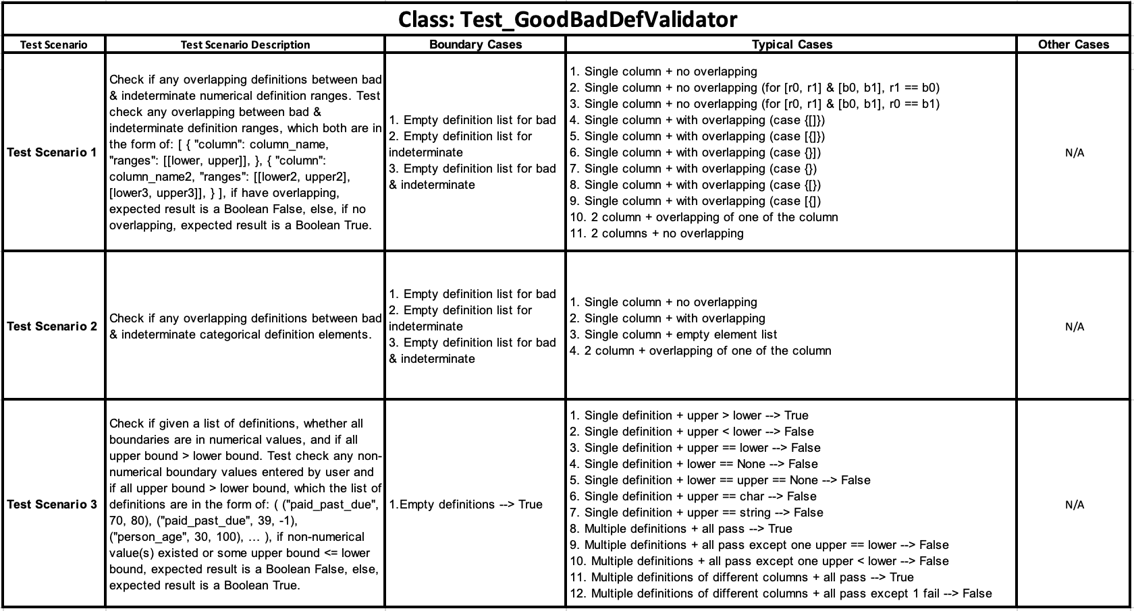

Appendix 2 - Test Scenarios 1-5 and test case details of GoodBadCounter class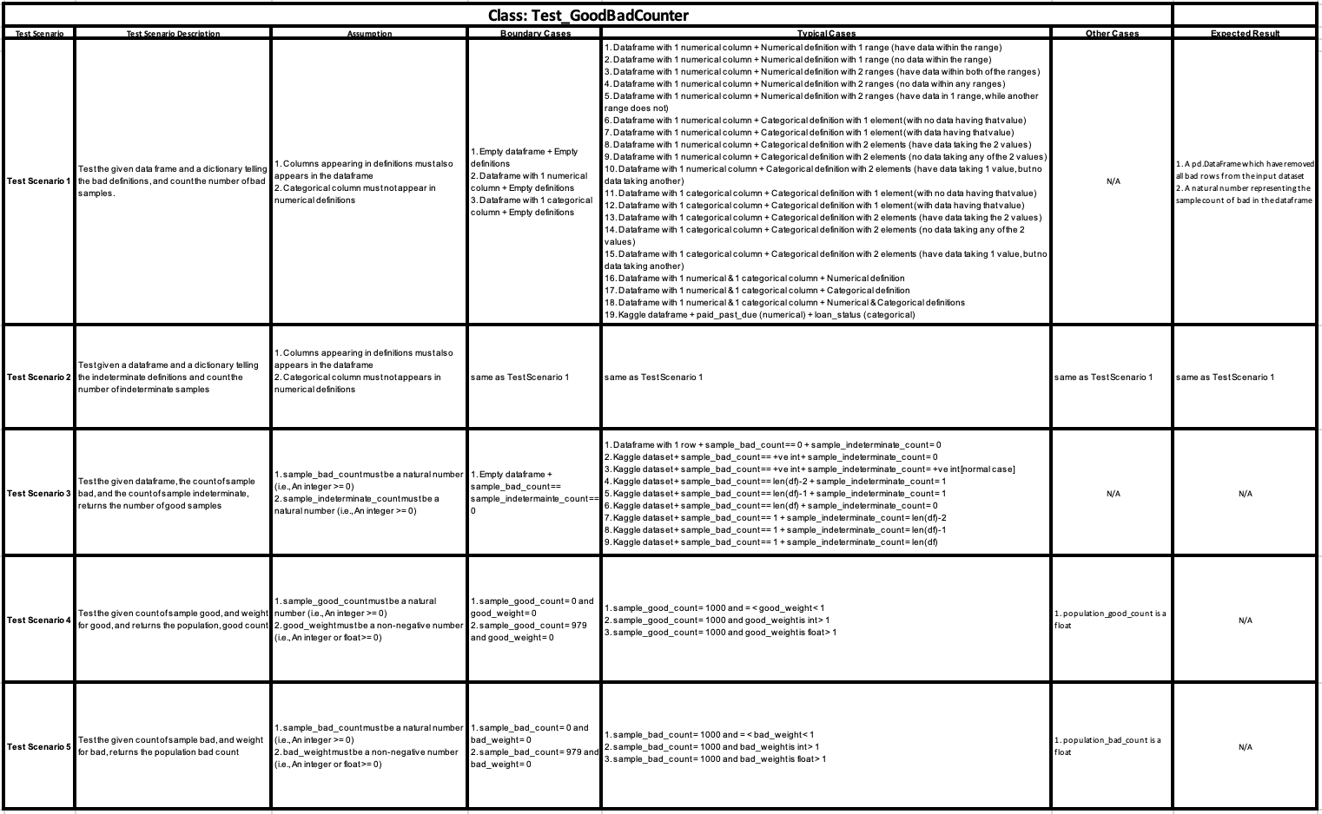

Appendix 3 - Test Scenario 6 and test case details of GoodBadCounter class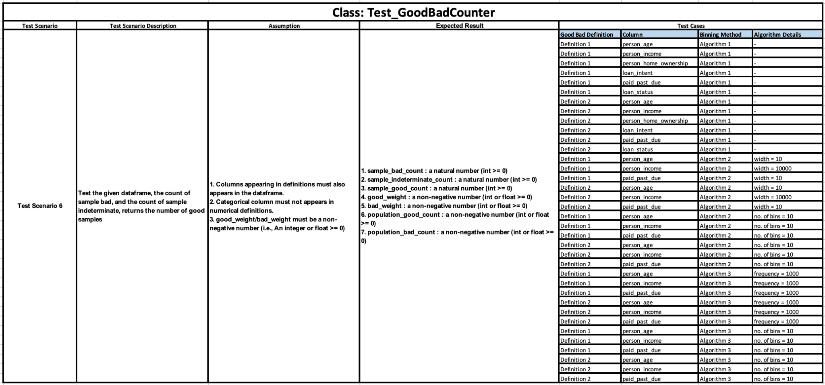

Appendix 4 - Test Scenario and test case details of StatCalculator class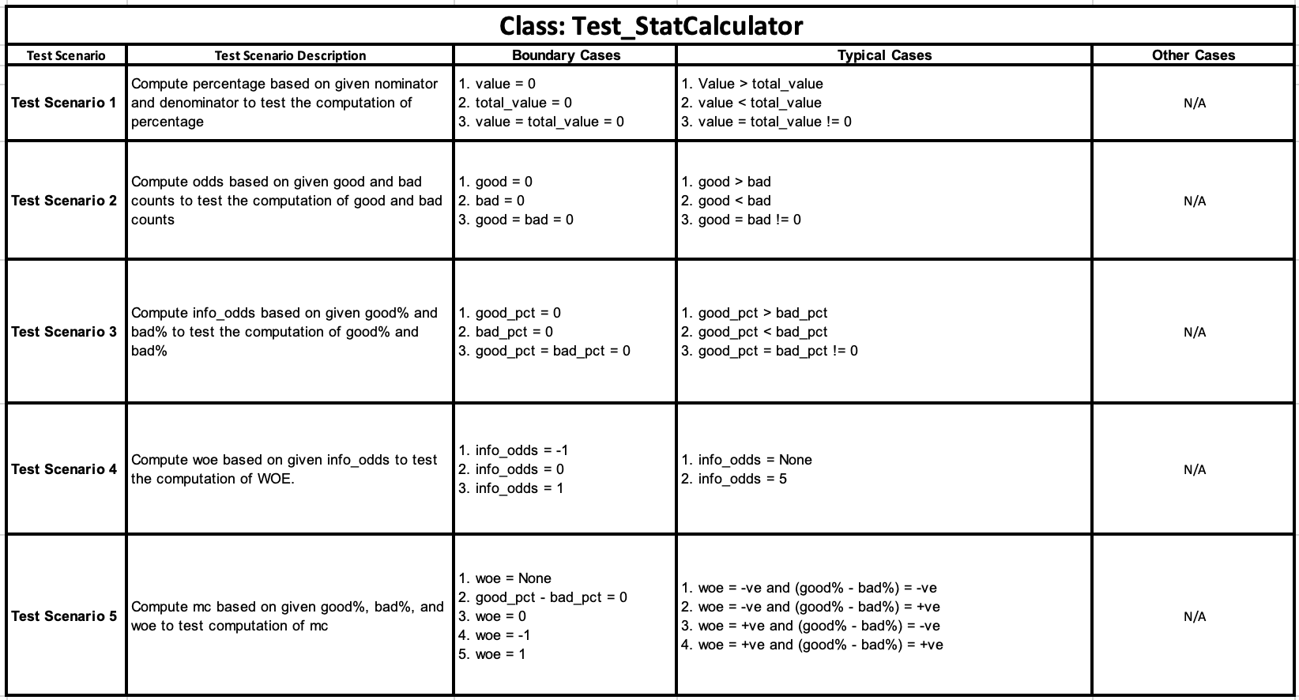

**4.3 Visualization Dashboard**

One of the two visualization dashboards mentioned in Section 3.5.3 has been completed, which is the one for automated binning. As shown in Figure 4.1, a Python recipe is implemented, taking the initial credit risk dataset as input, and outputting 11 different summary statistics datasets in total, one for each predictor variable. For each summary statistics dataset outputted, a Prepare recipe is applied on it to adjust the values to the required format as described in Section 3.5.3.1. Mixed charts are further generated for each summary statistics dataset outputted, consisting of a bar chart showing the frequency distributions of bins, and a line chart showing the WOE trend. A dashboard is built and 11 different sheets are prepared within the dashboard, one for each predictor variable. Each sheet consists of a summary statistics table, which is the dataset outputted from the Automated Binning Dashboard zone, and a mixed chart, generated using the Dataiku charting tools. Figure 4.2 and Figure 4.3 shows one of the sheets presented in the visualization dashboard in Dataiku. Figure 4.4 shows the timeline of our project.

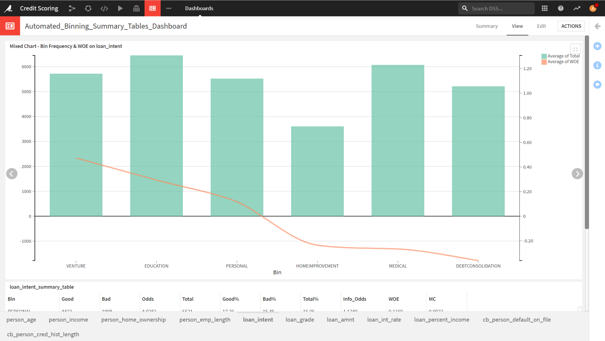

Figure 4.2 Mixed Chart for ‘loan_intent’ in a Dashboard Sheet

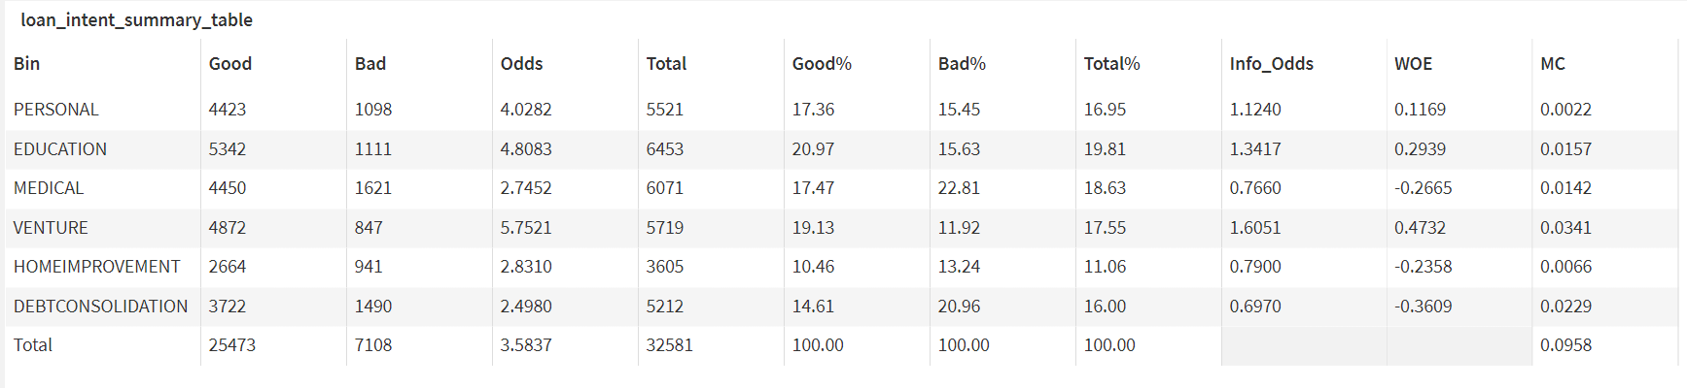

Figure 4.3 Summary Statistics Table for ‘loan_intent’ in a Dashboard Sheet